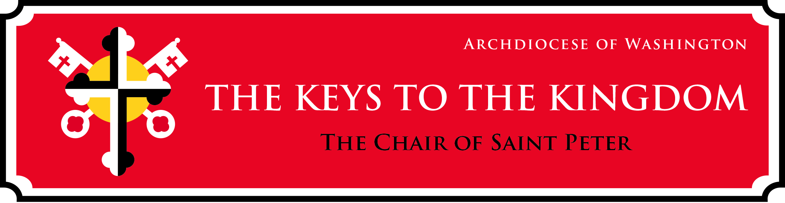
Catechesis on the Papacy
3- 5 Resource Guide: How is a Pope elected?
How is the new Pope chosen?
The special Church leaders, called cardinals, from all over the world come together in Rome, Italy to elect a new Pope. This is not like an election for mayor or president, because no one puts up signs or gives speeches about why they should be selected Pope. Secrecy is very important so that the cardinals are not influenced by other people. They promise not to use their cell phones, read newspapers, and they stay together at the Vatican the entire time of the election, whether it be days or weeks. The cardinals who will vote spend time praying and listening to the Holy Spirit in their hearts before they vote. This way, they know the man they elect as the new leader of the Church on earth is the one that Jesus would call if he were on the earth today, just like he called Peter.
The cardinals can vote up to four times a day, twice in the morning and twice in the afternoon, until they have reached a 2/3 majority vote, this man will be the next Pope. When they vote and don’t reach a majority the ballots are burned, and black smoke rises. They used to add wet straw to the ballots to make the smoke black, now chemicals are used. If they have elected a Pope, they burn just the ballots which makes white smoke. Because the cardinals are still in the locked room, the people waiting outside watch the chimney to learn whether a Pope has been elected or not.
Scriptural References:
Jesus declares Peter “the rock” and gives him “the keys”: Matthew 16:17-19
“Feed my Sheep”: John 21:15-17
Choosing Judas’ replacement: Acts 1:15-26
Council of Jerusalem: Acts 15: 1-35 (especially verses 6-12)

Suggested Activities:
- Pray for the successful election of a new Pope, have students write their own or use the “The Child’s Prayer for Religious Leaders” found at: https://www.loyolapress.com/catholic-resources/prayer/childrens-prayers/praying-for-others/childs-prayer-for-religious-leaders/
- Have students role-play a conclave: the week before your mock election, have students develop a papal motto of their own. On the day of the “election” gather in a room, join in silent prayer thinking about the mottos, before casting their ballots.
- Talk about the effect of the Holy Spirit on Peter at Pentecost. Peter had been a fisherman; now, he was to be a leader of men, a traveler and a public speaker.
- Set aside a “Chair of St. Peter” to be empty from April 21 until the election of the new Pope. Upon election of a new Bishop of Rome, use the chair to teach about the new pontiff. For information on the significance of the chair of St. Peter visit: https://www.loyolapress.com/catholic-resources/saints/saints-stories-for-all-ages/chair-of-peter/
- Have students brainstorm and write their own urbi et orbi (to the city and world) blessing.
- Pray for the 135 cardinal electors as they work to elect the next Pope. A list of the cardinals and their home countries can be found at: https://www.ewtn.com/catholicism/holysee/cardinals/electors

