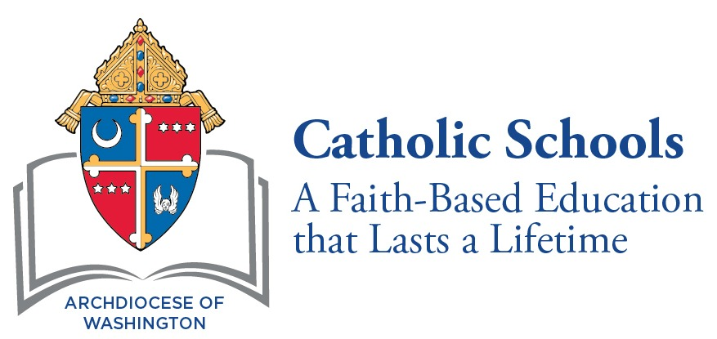

Golden Apple Award Application Form
Nominee Information
Congratulations!
You have been nominated for a Golden Apple Award. Please complete this form and return it to your principal by February 28, 2023.
Your Name: |  |  |  | Date:
Address:
Email: |  | Cell:
Parish:

School Information

Name and address of the school in which you presently teach:

School or Parish Pastor (Chaplain):

Name of Nominator:

☐ Parent and Student ☐ Teacher

Nominee’s Signature: |  | Date:

Nominee Information Form
Please have the Pastor of your school submit a letter of recommendation to you for inclusion in this packet.
Please have your principal submit a letter of recommendation to you for submission in this packet.

TEACHING EXPERIENCE
Dates  Start with most recent | School and Location | Courses Taught or Position

PROFESSIONAL DEVELOPMENT EDUCATION
Dates  Start with most recent | Institution and location | Degree

Certification
State Teacher Certification
ADW Catechetical Certification
Dates  Start with most recent | Type | Areas

Professional Upgrading and Other Courses
Include coursework, workshops, etc. in which you have participated in the past three years. Include any articles, books, or educational materials which you have had published.
Dates  Start with most recent | Course/Workshop

Professional Organizations
Indicate any leadership roles and describe any significant involvement.
Dates  Start with most recent | Name of Organization

Volunteer
Service to church.

Dates  Start with most recent | Service

Service to Community
Dates  Start with most recent | Service

Awards and Recognitions
Dates  Start with most recent | Service

Essay

As the nominee, you need to submit this essay, in size 14 font with a maximum of 500 words.

Essay Topic:
The role of the teacher in a Catholic school has many dimensions. What personal characteristics and teaching skills do you possess which enables you to be effective in a Catholic setting? Why do you teach in a Catholic school?

Checklist
Each nominee should be certain to include the following for submission to the principal.
Use this checklist to be certain that you have a complete and organized document. Document submitted to CSO should be a single document in PDF form.
Submitted document should be in this this order:
1. Application Form
2. Nominator’s Letter (Only one letter submitted)
3. Pastor’s Letter
4. Principal’s Letter
5. Nominee’s Essay
6. Proof of MD, DC, or VA State Teacher Certification
7. Proof of ADW Catechist Certification

