10 Steps for Teacher Training & Implementation of the
Personal Safety Education Program

- To begin, open your internet browser, such as Internet Explorer, Chrome, etc.

- At the home address bar in the web browser, type in this address: www.virtus.org

- Once you are at the Virtus System homepage, sign-in with your User ID and Password as normal.
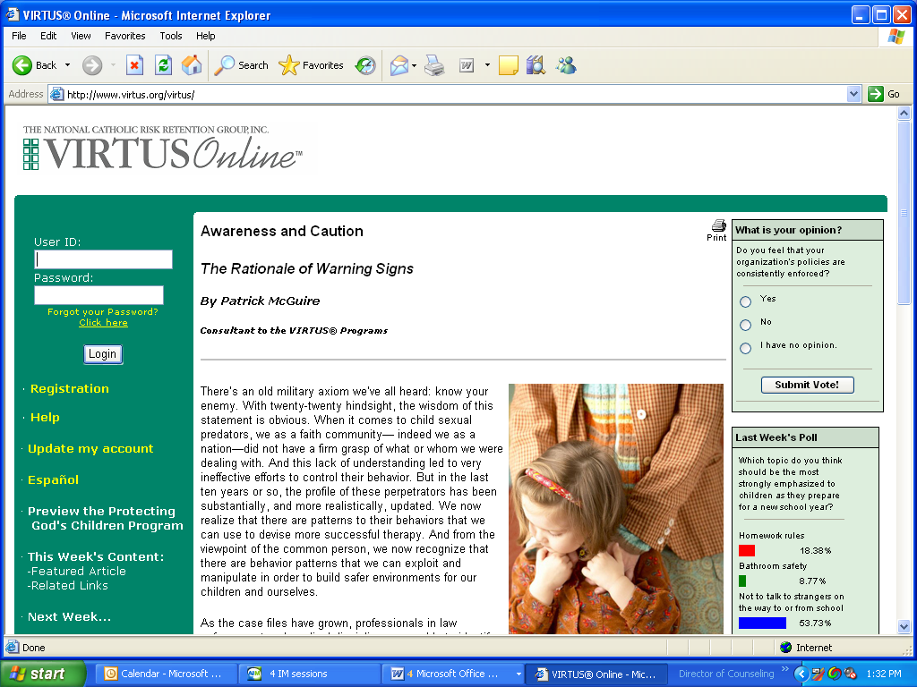

- Once you have successfully logged into the system, go to the tab titled, “Teachers” as seen below and using your cursor click on the tab:
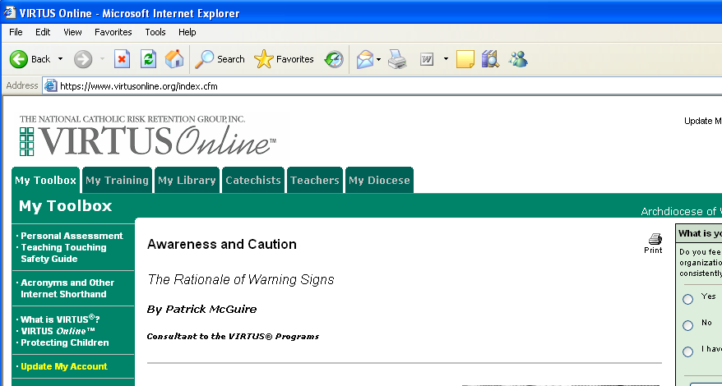

- Browse through the Teachers tab and its contents. Please follow the “4 Steps to Getting Started” found at the bottom of the webpage.
- Using the contents menu on the left-hand side of page, go to the link titled, “Lesson Plans”

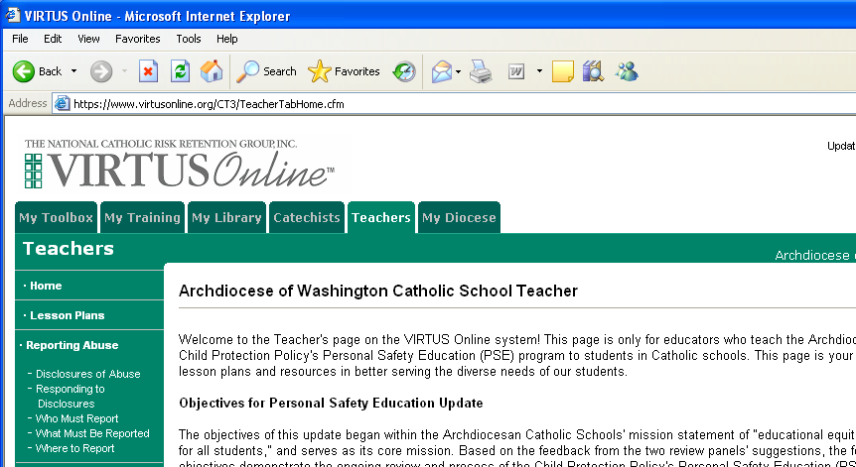

- Browse through the supplemental lesson plans which are grade and language appropriate to your students.
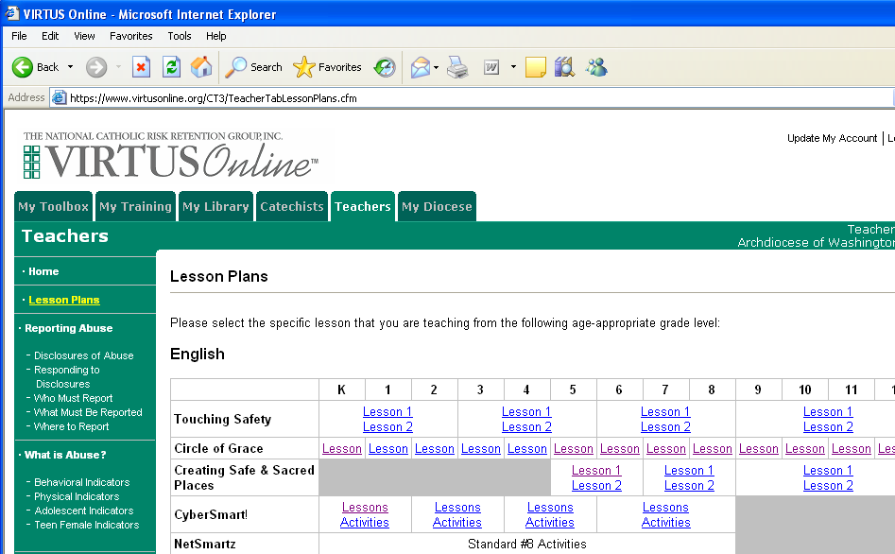

- Simply click on the blue link of the appropriate lesson plan and begin instruction.

- Once you completed the lesson, return to the Home screen and open the grade appropriate Standards Grid Sheet found in Step #4 of Getting Started
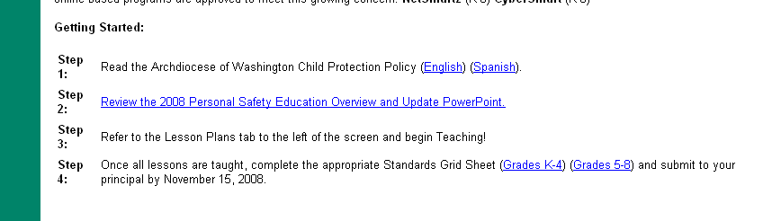
- Once your Standards Grid Sheet is fully completed, please submit the signed original copy to your principal by the first Friday in December. Thank you!

