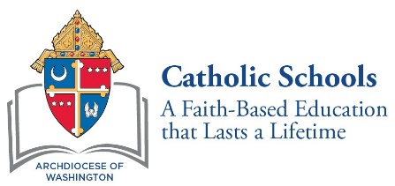

August 31, 2018

Dear 8th Grade Parents and Guardians,

This school year marks the start of a very exciting time in your child’s academic career. You and your child will soon apply to high school. As you prepare for the high school admissions and testing process, it will be important for you to be aware of the placement test requirements of each of the high schools. If you are considering applying to the Archdiocese of Washington Catholic high schools listed below, your child will be required to take the High School Placement Test (HSPT).

Catholic High Schools Requiring the High School Placement Test
Academy of the Holy Cross Gonzaga College High School
Archbishop Carroll High School Our Lady of Good Counsel High School
Bishop McNamara High School St. John’s College High School
DeMatha Catholic High School St. Mary’s Ryken High School
Elizabeth Seton High School St. Vincent Pallotti High School
Georgetown Visitation Preparatory School

For your convenience, the HSPT will be administered in school on Wednesday, November 28, 2018. In order for your child to take the HSPT, you must register for the test online. Registration opens on September 4, 2018 at 9:00 a.m. and closes on October 26, 2018 at 11:59 p.m. Additional information about the HSPT, including test format and cost, is available on the registration site. Click here to visit the HSPT registration site to complete and submit the online test registration and payment process.
I, together with your child’s 8th grade teacher, will provide guidance to help you and your child navigate the high school admissions and testing process to assist you in deciding on the best high school fit for you and your child.

Yours in Christ,

