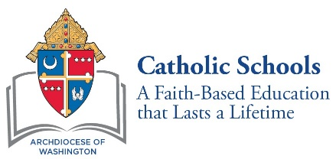

CATHOLIC HIGH SCHOOL VISITS TO ELEMENTARY SCHOOLS
2019-2020 ELEMENTARY SCHOOL STAFF AND PRINCIPAL FEEDBACK FORM

Name(s):

Elementary School: City:

High School Giving Presentation:

DATE OF PRESENTATION:

PLEASE CHECK THE RESPONSE THAT REFLECTS YOUR IMPRESSION AND PROVIDE COMMENTS, IF APPROPRIATE.

- Information about the unique Catholic identity of the Catholic high school was a prominent part of the high school’s presentation.

Yes ______ No ______ Comments:

- The high school’s presentation included information about the school’s academic programs, extra-curricular offerings, and admissions procedures and deadlines.

Yes ______ No ______ Comments:

- The high school representative arrived on time, introduced him/herself to the elementary school principal or principal’s designee,
and made a good impression.

Yes ______ No ______ Comments:

4. If alumni of the elementary school accompanied the high school representative during the visit, they were a positive part of the presentation.

Yes ______ No ______ Comments:

5. Negative allusions to other schools, such as negative comments regarding other schools’ perceived reputations, admissions criteria, etc. were not part of the presentation.

Yes ______ No ______ Comments:

6. The time limit for presentations was followed.

Yes ______ No ______ Comments

7. Giveaways (other than the application packet/brochure) were not included.

Yes ______ No ______ Comments:

Please email this form to williamsw@adw.org.

