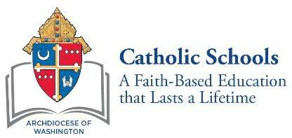

October 2020

Dear 8th Grade Parents and Guardians:

This school year marks the start of a very exciting time in your child’s academic career. You and your child will soon apply to high school. As you prepare for the high school admissions and testing process, it will be important for you to be aware of the placement test requirements of each of the high schools. If you are considering applying to the Archdiocese of Washington Catholic high schools listed below, your child will be required to take the High School Placement Test (HSPT).

Catholic High Schools Requiring the High School Placement Test
Academy of the Holy Cross Georgetown Visitation Preparatory School
Archbishop Carroll High School Gonzaga College High School
Bishop McNamara High School Our Lady of Good Counsel High School DeMatha Catholic High School St. John’s College High School
Don Bosco Cristo Rey High School St. Mary’s Ryken High School Elizabeth Seton High School St. Vincent Pallotti High School

For your convenience, the HSPT will be administered (Please insert the date and format you plan to test students). In order for your child to take the HSPT, you must register for the test online. Registration opens on Monday, October 26 at 9:00 a.m. and closes on Friday, November 20, 2020 at 11:59 p.m. Additional information about the HSPT and Catholic high schools in the Archdiocese of Washington can be found at www.adwcatholicschools.org. To register for the HSPT click here to complete and submit the online test registration and payment process. Please note this link will not be accessible prior to Monday, October 26.
I, together with your child’s 8th grade teacher, will provide guidance to help you and your child navigate the high school admissions and testing process to assist you in deciding on the best high school fit for you and your child.
Yours in Christ,

