Archdiocese of Washington
Office for Catechesis
Catechist Certification Tracking Sheet
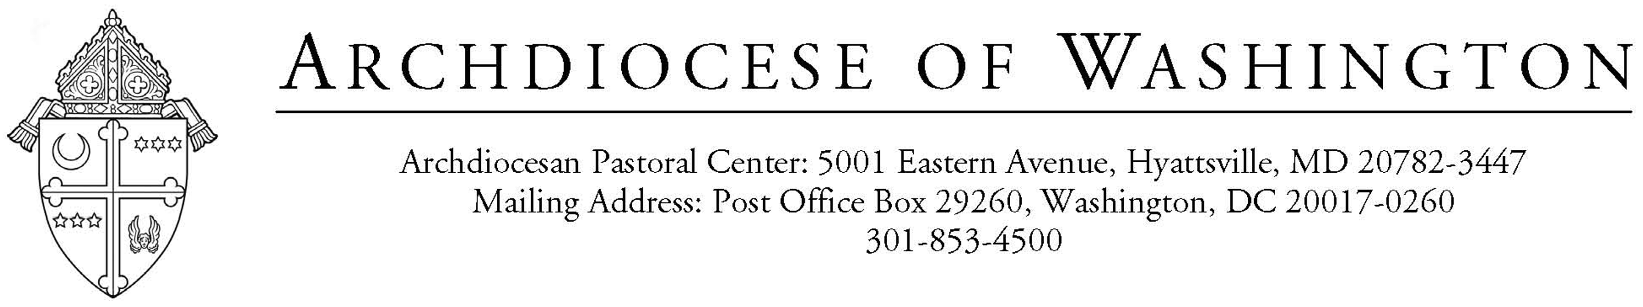

Catechist Name: _________________________________________________________________________

School Name: ___________________________________________________________________________

Date Hired to Teach Religion: _________________________________________________________

(Tracking sheet to be kept at school)

Fulfillment of Child Protection Policy as outlined by Archdiocese

 | Date Completed | Place (VIRTUS training only)
Screening/Fingerprinting
VIRTUS training

Listing of Courses for Certification

Please mark with “FF” for courses taken under Faith Foundations and mark with “HA” for courses taken under Hearts Aflame program. | Live Sessions | Online | Assessment\ Exemption | Date  Completed | Place  (If applicable, include parish/school name and city and state)
Living Catholic
Employees must take this in person.

Creed

Sacraments

Morality

Prayer

Scripture

Catechesis 101

Catechist Retreat
(Offered by Office for Catechesis)

