Archdiocese of Washington
New Principals 2019

Annunciation School, Washington DC
Rev. Msgr. Michael Mellone, pastor of Annunciation Parish is happy to announce that Nicole Peltier Lewis will be the next principal of Annunciation School in Washington, DC. Nicole has stated in her application, “I believe that following the model of Jesus as teacher and the great commission to make disciples creates for sound instructional and leadership practices. This is my foundation and has allowed me to practice humility, sound judgement and build communities of high expectations and excellence.” Nicole holds to her a Master of Arts degree with an Education Administration and Supervision major from George Washington University. She has served in the ministry of Catholic education as a catechetical leader, teacher and administrator since 2005.

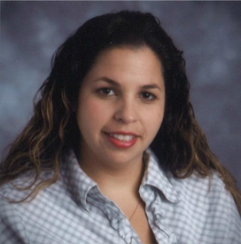
Holy Redeemer School, College Park, MD
Rev. Mark Smith, pastor of Holy Redeemer School, in College Park, MD has announced that Katrina Fernandez will be the next principal at Holy Redeemer School. Katrina holds a Master of Education degree in Educational Leadership, as well as a Bachelor of Education degree in Elementary Education and Psychology and is the former principal of St. Columba School in Oxon Hill, MD. She has over thirteen years of experience working in Catholic education. Katrina states in her application, “A Catholic school’s primary mission and vision should be to educate students effectively and form Disciples of Christ. It is the responsibility of the school leader to provide a path to realizing this vision. As a Catholic school leader, I place an emphasis on high academic standards and a strong Catholic identity. As the principal I will lead by example and be a role model to the faculty, staff, students, and parent community.”

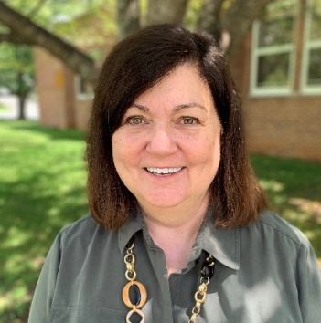
Holy Redeemer School, Kensington, MD
Rev. Mark Hughes, pastor of Holy Redeemer Parish in Kensington, MD has announced that Joan Hosmer will be the interim principal at Holy Redeemer School. Joan has served the students of the Archdiocese throughout her career. She was principal of St. Andrew School for four years, principal of Our Lady of Mercy for sixteen years and in the admission department at St. John College High School for the past four years. Joan stated, “I am so happy to have the opportunity to join Holy Redeemer Catholic School in Kensington this year. I have always found the best part of being a principal is the relationships that are formed with the people I have been blessed to serve. I have already been so warmly welcomed here at Holy Redeemer and I look forward to serving the Church by serving the people of this wonderful faith community.”
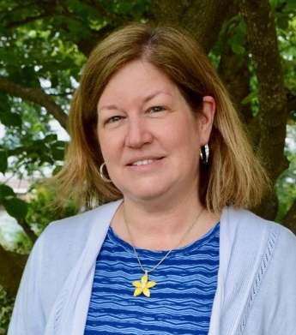
Our Lady, Star of the Sea, Solomons, MD
Rev. Ken Gill, Pastor of Our Lady, Star of the Sea Parish in Solomons, MD has announced that Jennifer Thompson will be the new principal at Our Lady Star of the Sea School. She has served the school as a teacher since 2004. Jennifer holds a Bachelor’s of science degree in English and Early Childhood Education. She is currently pursuing a Master’s in Administration from the Notre Dame of Maryland University. When asked about her role as new principal, Jennifer responded, “As a Catholic principal, I strive to model myself after the Master Teacher, Jesus Christ. I want nothing more than to lead others to Christ, particularly my students and to help increase their faith and lead them to experience relationship with God.”

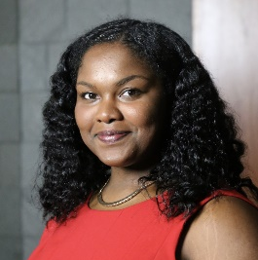
St. Ambrose School, Cheverly, MD
Rev. Charles Cortinovis, pastor of St. Ambrose Parish in Cheverly, MD has announced that Shakenya Humphries will be the new principal at St. Ambrose School. Shakenya grew up in the Archdiocese and attended Catholic elementary school at St. Peter School in Washington, DC and high school at Georgetown Visitation. Before coming to St. Ambrose Shekenya served as a lead teacher at Washington School for Girls, a Catholic School in Washington, DC. Shekenya holds two master’s degrees in Education. Shekenya stated in her application, “My mission within Catholic education is to support families and the Church in the mission of laying a Christian foundation of values and purpose under our youths’ feet as a way to steady their future actions. As a Catholic school leader, I hope to provide children the safe and supportive space to learn, explore, test boundaries, and discover who they are within the classroom and larger community.”

St. Columba School, Oxon Hill, MD
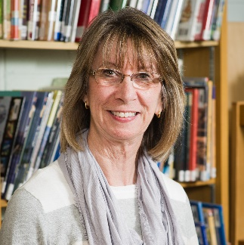
Rev. Gary T. Villanueva, pastor of St. Columba Parish in Oxon Hill, MD has announced that Christine Patton will be the interim principal at St. Columba School in Oxon Hill, MD. Christine holds a Master of Education degree in Educational Leadership, as well as a Bachelor of Arts degree in English. Before becoming interim principal, Christine was the assistant principal and a classroom teacher at St. Columba School. Christine was a member of the first graduating class of St. Columba School in 1969 and all three of her children are also graduates of St. Columba. Christine started volunteering at St. Columba when her oldest daughter attended Kindergarten in 1988. Since then she has held many hats from teacher to member of the leadership team. Chris stated, “I believe my experiences at St. Columba have prepared me to advance to the next chapter in my voyage, to be principal at the school that gave me so much guidance and support both spiritually and professionally throughout my life. I feel now is the time for me to give back to our school community the best way I know how, through service, knowledge , faith, and love of God.”

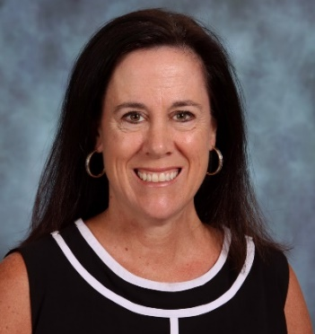
St. Elizabeth School, Rockville, MD
Rev. Msgr. Wilfrid Parent, pastor of St. Elizabeth Parish in Rockville, MD is pleased to announce that Mary Penny former assistant principal at St. Elizabeth School will be the new principal. As written in her application essay, “I am committed, as an educational minister, to share the good news of the Gospel and to provide our students with high quality spiritual formation in a faith community committed to academic excellence rooted in the teachings of Jesus Christ. My love for the students and families in the St. Elizabeth community and my passion for Catholic schools drive my desire to serve the church in the capacity of principal.”

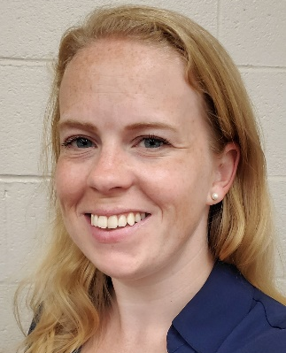
St. Mary of Assumption School, Upper Marlboro, MD
Rev. Thomas LaHood, pastor of St. Mary of Assumption Parish in Upper Marlboro, MD has announced that Ashley Lewis will be the new principal of St. Mary of the Assumption School. Ashley is a graduate of St. Mary of the Assumption School and Bishop McNamara High School. After graduating from the University of Maryland, Ashley served at St. Mary of the Assumption for almost six years in the roles of teacher and assistant principal. In 2016, Ashley’s husband received military orders to serve in Okinawa, Japan. In Okinawa, Ashley served as Child Development Center Director and Child Development Services Coordinator for Marine Corps Community Services. Ashley and her family are delighted to return to the area. About her return to St. Mary’s as principal, Nicole said, “I can think of no better way to continue my ongoing journey as a member of the Catholic faith than to lead a school so centered in its religious beliefs.”

St. Mary of Piscataway School, Clinton, MD
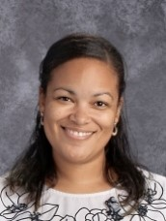
Rev. Timothy Baer, Pastor of St. Mary of Piscataway Parish in Clinton, MD has announced that Lynsie Reavis will continue this school year as interim principal at St. Mary of Piscataway School. Lynsie has assumed all duties of the principal since the December 2018 departure of the former principal. Lynsie has a bachelor’s of science degree in Elementary Education with an emphasis in mathematics and a Master’s degree in Educational Administration. Before accepting the interim principal position, Ms. Reavis was a teacher at the school. She started at St. Mary’s in 2009. When asked about her interest to serve the church as a Catholic school principal, Lynsie responded, “The Church has been a driving force in my life since I was born. As an adult, I know how important it is for me to give back that love and compassion to others. Being the principal of St. Mary's gives me an opportunity to lead with love. I became a teacher to spread God's love with my students. As principal, I can extend God's love to the whole school community. Every decision that I make if rooted in Christ and serving the community.”

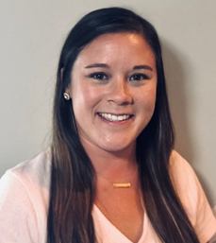
St. Peter School, Olney, MD
Rev. Thomas Kalita, Pastor of St. Peter Parish in Olney, MD has announced that Kristen Cocozzella will be the new principal at St. Peter School. Kristen has served as the school’s assistant principal since 2017. Before that, she taught Language Arts at Connelly School of the Holy Child in Potomac, MD. Kristen also taught language arts at St. Elizabeth School in Rockville, MD. Kristen holds a master degree in School Administration from Townson University. When asked to reflect on serving the church as a Catholic School Principal Kristen replied, “My experiences have led me to realize that a faith-centered community and exemplary pedagogy are the keys to success for our students. As a leader, I know how crucial it is to hold true to Catholic identity and be a strong spiritual leader. Students, teachers, and families need to be confident in the faith that binds us all together.”

St. Philip the Apostle School, Camp Springs, MD
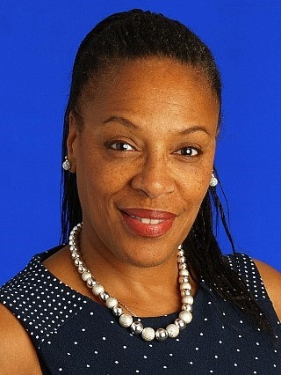
Father Lewis, administrator of St. Philip of the Apostle Parish, is pleased to announce that Deanna Johnson has accepted the position as interim principal of St. Philip the Apostle School. She will become principal on September 9, 2019. Ms. Johnson comes to St. Philip from Bishop McNamara High School, where she has served since 2010. At Bishop McNamara, she has held the positons of admissions director, dean of students, and Spanish teacher. In addition to her education career, Ms. Johnson is the director of Music Ministries and Choir at St. Peter Church in Waldorf, MD. Ms. Johnson holds a Bachelor of Arts degree in Political Science from Rutgers University and a Master’s degree in TED Secondary Education from University of Phoenix. Before beginning her work at Bishop McNamara, Ms. Johnson taught Spanish at St. Peter School in Waldorf. When asked why she wanted to serve as our principal, Ms. Johnson stated, “Being a Catholic educator is a true form of service because it is done in imitation of the greatest teacher, Jesus Christ. For me, the face of Christ can be seen in every child in my care. They have been entrusted to us in the hope that we will guide them through lessons rooted in the Gospel and form them into agents of peace, bringers of hope, and servants of God. I truly believe this is my vocation…I was led to the doors of His Church and embraced upon entering. I was served by those who love Him, and now I serve with them in His name…I can only live by His example.”

