Study Guide
Science Packet

Interpreting Concept Maps and Diagrams
In many subject areas, including science, visual representations, such as concept maps, models, drawings, blueprints, and other diagrams, are often used to convey or explain information. Students should be able to interpret concept maps and diagrams.

A concept map usually consists of shapes connected by lines or arrows. The shapes contain ideas or headings, and they are connected by lines to show how each shape is related to the others. The concept map below shows the different types of organisms that live in Lee's back yard.
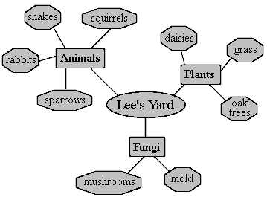
The oval in the center connects to three types of organisms: animals, plants and fungi. Each type of organism connects to specific living things in its own category. For instance, oak trees, grass, and daisies are the plants in Lee's yard. One can also tell by this concept map that mold is a type of fungus that is found in Lee's back yard. Even though there is no title for this concept map, it is clear that the map is displaying the different types of living things found in Lee's yard.
Diagrams, such as blueprints and drawings of models, are another type of graphical representation. Like concept maps, they can also show relationships between different parts or ideas. In addition, diagrams can show sizes, scale, shapes, locations, distances, or processes. The diagram below is of an electrical circuit. It shows the parts of a particular circuit and their locations.
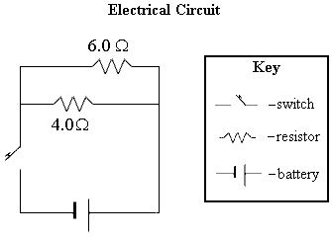
This diagram includes a key, which is common in diagrams. A key describes or defines symbols found in the diagram. In this diagram, the key shows what each symbol means.
Example: Use the diagram of the electrical circuit shown above to answer the following question. How many resistors does this circuit have?
A. 4
B. 6
C. 2
D. 1
Answer: C. The key shows that the symbol for a resistor is a jagged line. There are two of these symbols in the circuit, so there are two resistors.
To help students understand concept maps, have them make concept maps of their families. Their concept maps should be similar to family trees with grandparents or great-grandparents in a central location, branches out to each of their children, more branches representing their children's children, and so on. So that students may better understand diagrams, have each student draw a simple diagram of his or her bedroom. The student can draw what the bedroom looks like from above, using symbols for the different types of furniture and items in the room. Make sure students include a key that defines each symbol in the diagram. Finally, have them write the distances between different pieces of furniture in the room.

Matching Data to Graphs
A chart is a set of data organized into columns and rows. Charts are often used in science to display or record information in an organized way. Sometimes information from charts is represented in a graphical format to show changes and trends. Some examples are bar graphs, circle graphs (pie charts), and line graphs. Students should be able to match data from a chart to the best graphical representation of the information in that chart.

A chart has labels, called headings, that explain the type of information included. The chart below shows information on the growth of a plant over several weeks. Each week, the plant's height was recorded. The chart shows that the plant was two inches tall the first week, three inches tall the second week, five inches the third week, and seven inches the fourth week.
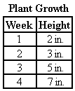
A graph is a pictorial way to display information. Most graphs have an x-axis that is horizontal and a y-axis that is vertical. The x- and y-axes meet at a corner that usually represents "zero" on both axes, unless otherwise labeled. The difference between the values on each axis is called the interval of the graph. The labels on the axes define what the numbers represent, including the units. Most likely, they are a measurement of an amount, such as height, weight, or time. The examples shown below explain different types of graphs.
A line graph is often used to show trends, changes over time, or how one factor affects another. The line graph below shows the information from the plant growth chart above. The numbers on the y-axis represent the plant's height in inches. The x-axis shows the weeks that the plant was measured. The interval on both axes is one because the numbers increase by one each time.
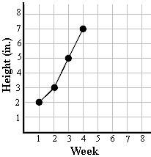
If you look at week one on the graph and follow it up the grid line until it reaches the data point, then follow the grid line to the left, it intersects the y-axis at a height of two inches. This information is the same as the information given in the chart; at week one, the plant was two inches tall. This can be verified for each data point.
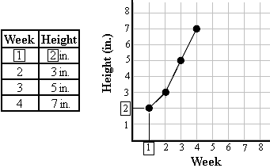
Bar graphs are another way to show quantities in a graphical format. They are usually used to compare items or describe different values. Like a line graph, a bar graph has an x- and a y-axis that show information. In this example, the information comes from the chart shown next to the bar graph. The numbers on the y-axis represent a plant's height in inches. The x-axis shows the type of plant that was measured. There are four bars on the graph, one bar representing each type of plant. The top of each bar represents the height in inches of that plant. If you look at the top of the bar for the elm and follow it over to the y-axis, you can see that it corresponds to a height of two inches. Each type of plant is a different height, so all of the bars on the graph are different heights. It is possible to have more than one bar with the same height, if more than one type of plant has the same measurement. Even if two or more values are the same, each item measured should have its own bar.
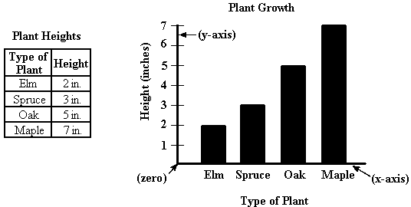
Bar graphs can also be oriented sideways. The bar graph shown above could also be made like this:
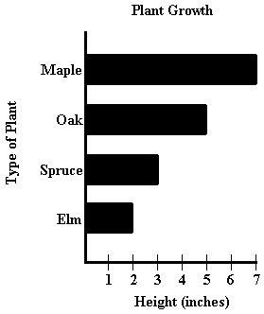
Circle graphs, sometimes called pie charts, are also used to display information. They often show percentages or parts of a whole. They do not have an x- or a y-axis. The data in the charts shown above would not be displayed in a circle graph because the charts show the specific measurements of one or more plants, not measurements as parts of a whole. The circle graph shown below illustrates the percentage of people in an apartment building that have blue, green, brown, or hazel colored eyes.
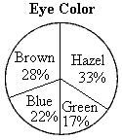
The information in this circle graph matches the chart shown below.
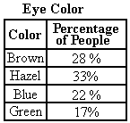
Example: Which graph below most accurately shows the information in this chart?
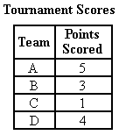
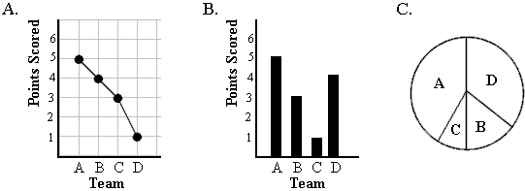
Answer: B. The bar graph accurately shows all of the information from the chart. The bar for each team is the correct height to represent the corresponding number of points, given in the chart. Also, (B) is a better graph to display the type of information given, which is a data set for a group, not a trend. (A) is not correct because according to that graph, Team A scored 5 points, Team B scored 4, Team C scored 3, and Team D scored 1 point. This does not match the information in the chart. Finally, (C) is not correct. Circle graphs show parts of a whole or percentages, which is not the type of information given in the chart.
To help students learn how to match data from a chart to graphical representations, have them make a line graph for chart 1 below, a bar graph for chart 2, and a circle graph for chart 3.
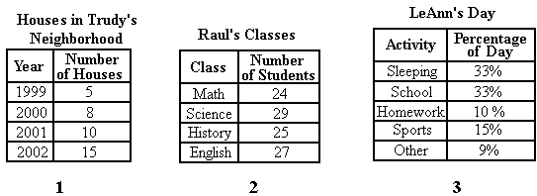

Inferences from Data in Charts
A chart is a set of data organized into columns and/or rows. Charts are often used in science to display or record information and numbers in an organized way. A chart has labels, called headings, that explain the type of information included. Inferences are logical conclusions that can be made after examining data. Students should be able to use the information from a chart to make inferences.

In any situation in which events happen and changes occur, there is always a cause or explanation. Those events and changes will in turn produce effects. Being able to see how different factors relate in any situation and being able to make predictions are important in science. When examining information in a chart, a scientist often looks for patterns or clues that may appear. Recognizing patterns and examining clues help them to notice cause and effect relationships and make inferences. If two sets of numbers increase or decrease at the same rate, or even if one consistently increases as the other decreases, it can be a clue that one is causing the change in the other. For example, the chart below shows information from an experiment on plant growth. Three plants of the same type and age were observed. The temperature of the area they were grown in, the amount of water they were given, and their total growth were recorded.
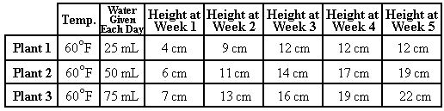
As you can see, the height of the plant increases as the amount of water given to the plant increases. We can infer that the more this type of plant is watered, the taller it will grow, and that the extra water caused plant 3 to grow more. Also, observe that Plant 1 is the same height at weeks 3, 4, and 5. From this, we can infer that the plant stopped growing after week 3.
Example: The chart below shows the conditions at Mission Lake on four different days and the number of frogs present on each day.
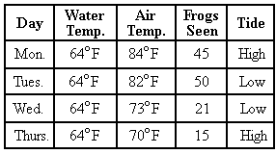
What most likely caused more frogs to be seen on Monday and Tuesday than on Wednesday and Thursday?
A. the water temperature
B. the air temperature
C. the tide
Answer: B. From the data in the chart, the most likely factor that contributed to the number of frogs seen is the air temperature. As shown in the chart, many more frogs were seen on Monday and Tuesday than on Wednesday and Thursday. Since the water temperature was the same every day, it probably did not affect the number of frogs seen, so (A) is incorrect. The tide is different on Monday and Tuesday, so it does not correspond to the high numbers of frogs seen on those two days. If the tide had been a factor affecting the number of frogs seen, there would have been many frogs seen on only one of the days (either Monday or Tuesday) and few seen on the day with the opposite tide. Therefore, (C) is incorrect.
To help students understand how to make inferences using the data in charts, have them find data from an old experiment that they conducted or data from a lab or science book. They should try to find patterns and explain what caused any apparent changes or differences in the data. Also, they can write down ten events (or effects) they have learned about in science along with the corresponding cause for each event or effect: for example, a plant turning yellow and dying (effect) and the plant's soil not having the proper nutrients (cause).

Skeletal and Muscular Systems
The skeletal and muscular systems are the systems of the body that help us move. Students should know the functions of these systems, know their component parts, and understand that they work together.

The skeletal system gives the human body shape, rigidity, and structure. There are over two hundred individual bones that make up the human skeleton. Bones have a hard exterior with a softer center called the bone marrow. A spongy material, called cartilage, cushions the ends of bones. In addition, it is cartilage, not bone, that shapes the ears and the nose on humans. The following diagram shows the location and general shape of some of the major bones in the human body, including the skull, clavicle, vertebrae, humerus, rib cage, sternum, pelvis, and femur bones in the human skeleton.
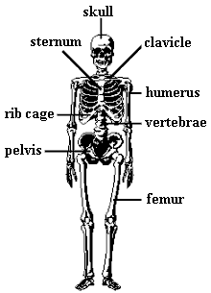
A joint is formed where bones come together. There are four basic types of moveable joints: ball and socket, hinge, pivot, and gliding. Ball and socket joints allow movement in all directions. The shoulder and hip are examples of ball and socket joints. Hinge joints allow bones to move together and apart, like in the knee and the elbow. The skull and vertebrae come together and form a pivot joint. Pivot joints allow movement up and down and rotation from side to side, like the bones in your neck. Gliding joints can be found in the ankles and wrists, where bones move back and forth, and from side to side. Stretchy, rubber band-like ligaments hold the bones together at the joints. The following diagrams show the four types of joints, with arrows indicating the directions of their movement.
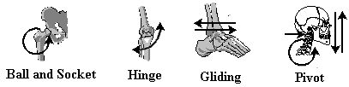
The skeletal and muscular systems are dependent on one another. Muscles are attached to the skeleton in many places because the muscles of the body help the skeleton move. They are attached to bones by bands of tissue called tendons. Without muscles, the body could not move.
Muscle tissue contracts, or squeezes together, and relaxes in order to move the parts of the body. An example of this is the relationship between the bicep muscles in the front of your arm and the tricep muscles opposite to the biceps. When you touch your right shoulder with your right hand, your biceps contract, while the triceps on the other side relax. To stretch the arm back out and hold it flat, the triceps must contract while the biceps relax. Many muscle groups throughout the body share this same type of relationship.
The following diagram shows the location of the abdominal muscles, the bicep, the quadricep, the tricep, the hamstring, and the gluteus muscles in the human body.
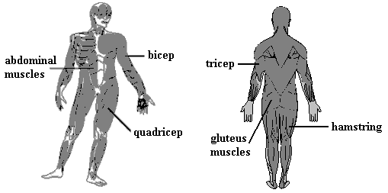
There are three different types of muscle tissue. They are smooth muscle, cardiac muscle, and skeletal, or striated, muscle. The muscles shown in the diagram above are all skeletal muscles. Skeletal muscles are attached to bones and help move the skeleton. They are voluntary muscles, meaning you can consciously make them move. Smooth muscle is found in internal organs. These muscles are involuntary, which means that you are not able to consciously control their movement; they help organs perform certain functions. For example, the smooth muscles of the stomach churns food during digestion. Finally, cardiac muscle is only found in the heart. This type of muscle also moves involuntarily.
To help students understand the skeletal system, have them try to find items around the house or at school that look or work like the different types of joints. A door hinge (hinge joint) and a nut and bolt (pivot joint) are two examples. Another activity students can complete, to help them learn muscles and bones in the muscular and skeletal systems, is to draw a picture of a person. On the picture, they should label the major bones and muscles. Finally, students can make different movements and try to guess which bones, muscles, and joints are moving.

Land Biomes
On earth there are areas that share the same climate and soil conditions, as well as plant and animal life. These areas are called biomes. There are seven major land biomes: tundra, deciduous forest, desert, grassland (savanna), chaparral (scrubland), wetland, and tropical rain forest. Students should be able to describe the characteristics of each biome, as well as recognize some of the plant and animal life that inhabit each biome.

The tundra biome is a treeless, cold area, located in the Arctic Circle. The tundra is treeless because it does not receive enough of the sun's energy to allow for large plants to produce their own food. The plants that live in the tundra are lichens, mosses, and grasses which grow right along the ground, and have very small leaves. Just below the surface of the tundra, the soil stays frozen year-round which inhibits deep root development in plants. This layer of soil is called permafrost. Polar bears and brown bears use the tundra for hunting fish and small rodents. Birds, moose, caribou, and insects migrate to the tundra during warmer summer months to feed and reproduce.
Deciduous forests are located in areas that experience cold winters, warm springs and summers, with seasonal sunlight and rainfall. The plant life in the deciduous forest includes trees, shrubs, and other plants that can live in shadows cast by trees. During fall, the leaves on the trees in deciduous forests change colors, and the trees lose their leaves by winter. Lichens, mosses, and fungi also live in deciduous forests. Because of the abundance of plant life, a variety of animals inhabit the forest. Black and brown bears, deer, rodents, birds, insects, spiders, cats, foxes, wolves, caribou, moose, as well as some amphibians and reptiles, can make their homes there finding plenty of food, water, and shelter.
The desert is a biome that receives very little to no rainfall. Plants in the desert must be well adapted to the harsh temperatures and lack of moisture to survive. In hot deserts, the majority of plants are cacti and grasses, which have special stems for storing water. The animals in deserts must be able to live off of these specialized plants as well as deal with the lack of moisture and extreme temperatures. Certain lizards, tortoises, snakes, rodents, insects, birds, and spiders can live well in a desert. Most of the animals in a desert biome are nocturnal, which means they are mostly active at night when the temperatures are cooler.
The grassland, also called the savanna, is a biome with few or no trees. The primary plant life consists of grasses which depend upon streams, seasonal rainfall, and plenty of sunlight to meet their needs. The wide-open space of the grassland is attractive to migrating and herding animals such as buffalo, horses, deer, antelope, and cattle. Ducks, geese, songbirds, hawks, and falcons, can live in grasslands depending on the amount of water and food that exist there. Larger animals such as foxes, wolves, lions, cheetahs, and hyenas migrate to the grassland as long as there is plentiful prey and enough shelter. Small rodents, reptiles, insects, and amphibians find grasslands ideal for feeding on plants.
Chaparral, sometimes called scrubland, is a biome located in coastal areas where the climate is moderate, but the environment can be harsh. Rainfall is not predictable, and these areas can experience flooding at times. Winds are strong and the soil is loose and sandy. Plants have adapted to the chaparral by limiting their height, and their leaves tend to be small and dense. Small birds, reptiles, insects, and some rodents live in the chaparral biome. Larger animals migrate there to feed, but the plant life is not ideal for sheltering their larger bodies.
A wetland is a biome that exists where fresh water sources from the land collect in a low lying area. A wetland is sometimes called a swamp or estuary. Many of the trees, grasses, mosses, and shrubs live directly in the water. They may have root systems that grow into the muddy and sandy bottom of the wetland, or may simply float in the water, trailing their roots underneath or beside them. Like the plants, the animals in a wetland spend most of their lives in the water. Alligators, crocodiles, snakes, lizards, amphibians, insects, and birds have adaptations that allow them to move, find shelter, and feed easily in this watery environment. Insects of many kinds find the wetland attractive because of the mild climate and large amount of water. Some rodents make their homes in wetlands, while many fish live in the waters.
The tropical rain forest is the biome with the most diversity in plant and animal life. Tropical rain forests circle the globe, at the equator, on all continents. Near the equator, the temperature is always warm, there is always plenty of sunlight, and much rainfall. Plants with wide, glossy, green leaves live very well in this hot, humid climate. Trees of great height create a canopy, or roof-like covering, over the top of the forest with their branches and leaves. Sometimes this canopy is so thick that no sunlight reaches the forest floor. The layers of plant life in the rain forest learn to adapt to the amount of sunlight they receive, and grow strong from the abundance of nutrients in the soil. The variety of plant life in the rain forest is equaled only by the diversity of animal life. In no other biome can so many animals - insects, birds, reptiles, amphibians, arachnids, rodents, apes, monkeys, cats, bears, boars, bats and humans - live together and have their needs met.
The following activities will help students learn about land biomes:
Activity 1: After developing a color key to identify each of the seven land biomes, students can use a map and the color key to color-code parts of their own country that represent certain land biomes.
Activity 2: Have students cut out or draw pictures of animals that live in certain biomes around the world. Students can label each picture with the name of the biome where the animal lives.
Activity 3: Making flashcards with a biome fact on one side, and the name of the biome on the other will help students remember the basic characteristics of each land biome.

Flower Parts and Functions
Students should understand the process of reproduction in flowering plants, including the flower parts necessary for reproduction.

The following diagram shows the general shape and location of the parts of a flower.
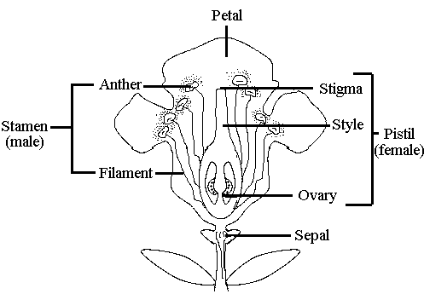
The petals protect the interior flower parts and attract insects.
The sepal is a small leaf-like part on the bottom of the flower that protects the young flower (bud).
The stamen is the male reproductive structure of the flower and is made up of the anther and filament. It produces powdery pollen grains which are the male sex cells of the flower.
The filament holds up the anther.
The anther produces and holds pollen.
The pistil is the female reproductive structure of the flower and is where seeds are produced. It is made up of three parts: the stigma, style, and ovary.
The stigma is the opening of the ovary.
The style is a tube connecting the stigma to the ovary.
The ovary is where the eggs, the female sex cells of the flower, and seeds are produced.
Flowering plant reproduction begins with a process called pollination, during which pollen is carried to the stigma by wind, insects, or other means. Insects and other animals often carry pollen between flowers. They are attracted to the petals' bright colors and perfumes. After pollination, the pollen grain makes its way down the style into the ovary. Once in the ovary, the pollen grain will unite with the egg. This union is called fertilization. After fertilization, seeds begin to develop inside the ovary. As the seeds grow, the ovary swells and hardens to protect the seeds.
To study the process of plant reproduction, students can make a flow chart showing the steps of reproduction, including the parts of the flower involved. Also, students can find various flower samples and identify their parts. The interior parts of a flower can be observed by removing one or two petals. Different flowers have different forms of flower structures. After identifying the structures inside the flowers, students should discuss each structure's role in reproduction.

Population
Students should understand the biotic and abiotic factors that impact population sizes in an environment, including the concepts of sustainability, limiting factors, biotic potential, and carrying capacity.

Living things in an environment, such as trees and animals, are called biotic factors. Non-living parts of an environment, such as amount of sunlight, climate, soil, and cleanliness of the air, are called abiotic factors. A population is a group of the same type of organism in an ecosystem. Populations increase and decrease in number, based on the birth rates as well as how long organisms survive.
A limiting factor is a specific biotic or abiotic factor that stops a population from increasing. Sometimes an area has plenty of water, space, and clean soil, but there are not enough mice for the owls to eat. The lack of food may be the limiting factor for the owl population, because without food, fewer owls will survive and the population will decrease. After a few seasons, the mouse population may increase because there are fewer owls to kill them. The mouse population could reach its biotic potential, where the conditions of the environment are just right for the maximum capacity of mice to survive and reproduce. If too many mice are present though, the population may reach carrying capacity. The carrying capacity is the maximum population size that an ecosystem can support before food, water, shelter, or space begin to run out. These shortages will eventually affect reproduction and survival, and therefore limit the population.
Sustainability is the ability to maintain, support, or provide for something. An environment reaches sustainability when there are enough resources, space, and diversity so that the needs of all organisms are being met. Sustainability in an environment is important because it means an environment can allow many different organisms to survive for a long time. Without sustainability in an environment, population numbers fluctuate greatly or carrying capacity is reached quickly.
Example: Eagles eat fish. If the lake in the eagles' habitat becomes extremely polluted, how will the eagle population be affected?
A. The eagle population will increase.
B. The eagle population will decrease.
C. The eagle population will stay the same.
D. The eagle population will reach their biotic potential.
Answer: B. If the lake is extremely polluted, the fish that live there will die. Since the lake is in the eagles' habitat and is where they get fish, the eagles will not have enough food. This will decrease the eagle population.
To understand populations and how they change, students can write a short story about a specific environment and the changes in a population there. They should include details about both biotic and abiotic limiting factors, effects on other organisms in the environment, and when the population may have been at its biotic potential or carrying capacity. Students should try to focus on one or two types of organisms instead of all organisms in the environment.

Material Cycles
Students should understand how materials in the environment, such as water, nitrogen, carbon, and oxygen, are distributed, replenished, and cycled. In addition, students should understand the impact of environmental changes on the material cycles.

One example of a material cycle is the water cycle. Water from oceans and lakes is heated by the sun and turns into water vapor, a gas, in a process called evaporation. The vapor enters the atmosphere, cools, and turns into droplets, called condensation. Condensation is what forms clouds. The clouds move over land and release snow, hail, or rain, called precipitation. As the water falls to earth, several things can happen. Some of the water runs off the land into streams or rivers, or it seeps into the soil to become groundwater. Groundwater is water that is found underground in spaces between soil particles or rocks. The streams and rivers eventually empty water back into lakes or oceans. Water can also seep into the ground where plants absorb and use it. As water is used by plants, it reenters the atmosphere through transpiration, a process where plants give off water vapor. As water evaporates, the process repeats itself. The following is an illustration of the water cycle.
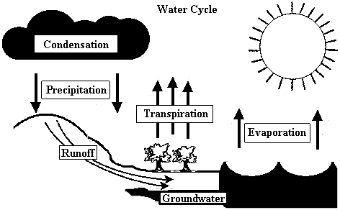
All living things need nitrogen to live. Though our atmosphere is about 78% nitrogen, it is not in a form useable to many organisms. In the nitrogen cycle, nitrogen gas in the air is converted to useable nitrogen. This process begins with bacteria in the soil and on the roots of plants. These bacteria, called nitrogen-fixing bacteria, use the nitrogen in the air and convert it to nitrates in the soil. Nitrates are nitrogen compounds that can be used by plants. Plants absorb the nitrates from the soil to use in photosynthesis, a process by which plants make their own food. Animals get the nitrogen they need from the plants that they eat. When plants and animals die or produce waste, decomposers in the soil break down the material and convert it to nitrates. Some of the nitrates are broken down further by other bacteria, which release nitrogen gas back into the atmosphere. The following is an illustration of the nitrogen cycle.
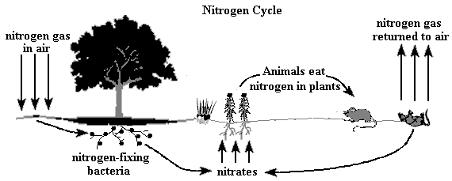
The carbon and oxygen cycles work together because both elements are combined in our air as carbon dioxide. The carbon from carbon dioxide is used by plants in photosynthesis, and oxygen is given off during the process. Oxygen is used by animals and plants in respiration, or breathing, and carbon dioxide is released. Respiration is the process where the cells exchange gasses with the environment. Like nitrogen, carbon is also stored in plant tissues, which are then eaten by animals. After organisms die, their decomposed tissues release carbon dioxide into the atmosphere. The following is an illustration of the carbon and oxygen cycle.
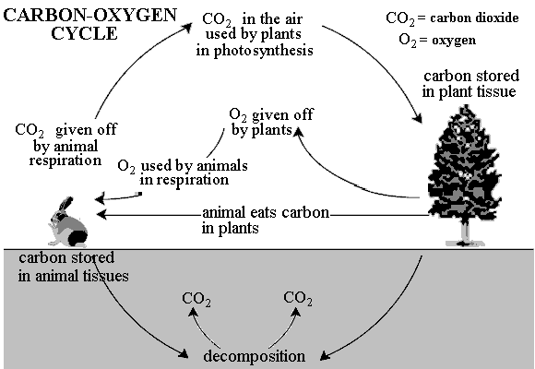
Any change that effects the materials involved in these cycles can in turn affect the environment in some way. For instance, if all of the plants in an area were removed due to clear cutting or development, the water cycle would be affected. Transpiration, an integral part of the water cycle, would not take place in that area. The nitrogen cycle would be affected because there would be no plant roots to convert nitrogen in the air to useable nitrogen in the soil. Also, animals in the area would not have plants to eat in order to obtain the nitrogen they need. Finally, the carbon and oxygen cycle would be disrupted in that area. Since there is no photosynthesizing plants, there is no oxygen production.
To understand material cycles, students can draw a diagram of each of the cycles, showing all materials and where they originate. All the underlined terms discussed here should be included.

Cell Parts - A
Students should be able to differentiate between a plant and animal cell and know the location and function of the following cell parts: nucleus, cytoplasm, cell membrane, cell wall, chloroplasts, lysosomes, vacuoles, and mitochondria.

The following diagram shows the cell parts, or organelles:
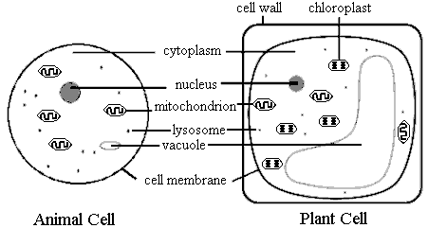
The cell membrane is the layer that surrounds the cell, protects it, and allows some materials to pass in and out of the cell.
The cell wall is an extra layer on the outside of plant cells that is rigid to give the plant support and prevent loss of moisture.
The cytoplasm is a thick jelly-like substance inside the cell in which all of the organelles are suspended.
The nucleus is an organelle on the inside of the cell that controls the functions of the cell and contains genetic material.
Chloroplasts contain green pigments found in all green parts of plants, especially leaves. They are the organelles in plants where photosynthesis, the process in which plants make their food using the sun's energy, occurs.
Vacuoles are used for the storage of water, food, or wastes inside the cell.
Lysosomes contain enzymes to digest materials inside the cell.
Mitochondria provide energy for the cell by breaking down nutrients.
There are a few specific differences between plant cells and animal cells. Animal cells do not have a cell wall and they have small vacuoles or none at all. They also do not have chloroplasts so they cannot make their own food. However, plant cells have a cell wall, large vacuoles, and chloroplasts.
To learn more about cell structure, students can observe the parts of onion cells and skin cells using a hand lens or microscope. Students can draw what they see and label the organelles that can be distinguished. If a hand lens or microscope is not available, you can find several books in the library that have pictures of plant and animal cells. Using the pictures of plant and animal cells, students can note the differences between the two and identify all parts and functions.

Cell Division and Reproduction
Cell division is a reproductive process in which cells divide to create more cells. There are two main types of cell division processes: one for sexual reproduction, known as meiosis, and one for asexual reproduction, known as mitosis. Students should know the similarities, differences, and basic characteristics of sexual and asexual reproduction, including the main steps of the cell division processes.

To understand these processes, it is important to understand genes and chromosomes. Genes control heredity, the transfer of characteristics from parents to offspring, and determine the traits that will be expressed. Genes link together to form chromosomes. Chromosomes are the structures that carry genes and are usually found as pairs.Sexual reproduction requires two different sex cells, a sperm and an egg, called gametes. The sperm is the male gamete, and the egg is the female gamete. These two gametes must unite, in a process called fertilization, to produce offspring. If fertilization does not occur, cell division will not begin and the organism will not develop. Gametes only have half the normal number of chromosomes so that when they unite, they produce an organism with the correct amount of genetic material. Since two different gametes from two separate individuals unite in sexual reproduction, the offspring receive a combination of genetic material from each parent. Half the genetic material is from the father, and half is from the mother. This mixing produces variation among the offspring of sexual reproduction. Humans are an example of an organism that reproduces sexually. Meiosis is the sexual cell division process that produces the gametes necessary for sexual reproduction and is shown below with a explanation of each numbered step.
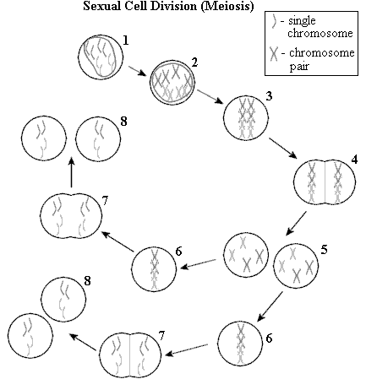
1. This is the original cell that is about to undergo meiosis.
2. The chromosomes duplicate so there are now two copies of each chromosome.
3. The chromosome pairs align.
4. The chromosome pairs separate and the cell begins to divide.
5. The cell has divided into two cells.
6. The chromosomes align.
7. Individual chromosomes separate and the cell begins to divide.
8. The cell has divided into four cells total, each with half the number of chromosomes as the original cell.
Asexual reproduction requires only one cell and is necessary for the growth and repair of cells. This cell division process is called mitosis. During mitosis, the original parent cell will divide into more cells and will pass on exact copies of its genetic material to its daughter cells. Since there is no contribution of genetic material from another cell, the daughter cells will be identical copies of the parent cell. There is no variation among asexually reproduced offspring. Mushrooms are an example of an organism that can reproduce asexually, with spores, instead of gametes. The asexual cell division process is shown below with a explanation of each numbered step.
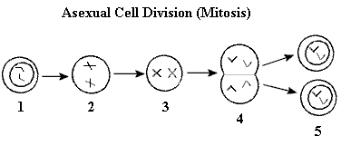
1. This is the original (parent) cell about to undergo mitosis.
2. The chromosomes duplicate and begin to move.
3. The chromosome pairs align.
4. The chromosome pairs separate and the cell begins to divide.
5. The cell has divided into two identical cells.
To study this topic, students can make a table that includes all of the characteristics of sexual reproduction and all of the characteristics of asexual reproduction. Also, they can research examples of organisms that reproduce sexually, and ones that reproduce asexually. Finally, students can make a flipbook to show each cell division process. Draw the steps of each process on a separate sheet of paper in the bottom corner. Stack the sheets in reverse order, with the first step on the bottom and the last step on top. When the pages are flipped through quickly, the book will show the process in action.

Characteristics of Life
Students should understand that there are several characteristics that all living things have in common, including those that occur at the cellular level, and should be able to list these characteristics.

All living things require energy, can reproduce, dispose of wastes, are organized and complex, grow and change, respond to the environment, and are made of one or more cells. Although different organisms may exhibit these characteristics in various ways, they must have all of these characteristics to be considered living.
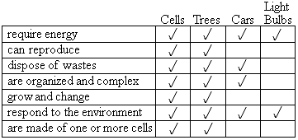
All organisms require energy so that they can carry out certain life processes, though the method they use to obtain energy varies. For example, organisms can get energy by eating other organisms (animals), absorbing decomposed minerals and nutrients (fungi), or making their own food through a process called photosynthesis (plants). During these processes, organisms produce waste products that must be released. For example, plants release wastes into the air through their leaves. Another process carried out by living things is reproduction. Organisms must reproduce to ensure the continuation of their species. Organisms also grow and change throughout their lives and respond to the environment for survival. For example, plants may respond to sunlight by growing towards the sun to get more light. Finally, organisms are organized by complex systems that function together to help each organism meet its needs.
All living things are composed of one or more cells (organisms made of one cell are called unicellular, and organisms made of more than one cell are called multicellular), and each cell exhibits the characteristics of life. For instance, all cells require energy to carry out their various functions. Through processes called digestion and respiration, cells are able to obtain valuable nutrients and energy. Waste is produced by cells, and must be disposed of in a process called excretion. Cells are able to reproduce by dividing. Cells are organized by their parts and each part has its own function. Cells can grow, change, and respond to their environment.
Example: Which of the following is NOT a living thing?
copy machine tree mushroom paramecium
Answer: The copy machine. A copy machine may require energy and be able to reproduce, but it is not composed of cells, cannot grow, and cannot dispose of wastes. A tree, a mushroom, and a paramecium can do all of these things. Paramecia are only made of one cell, but they have all the characteristics listed above, so they are considered living things.
To understand the characteristics of living things and the differences between living things and non-living things, students can think of more examples of non-living things that show some, but not all, of these characteristics.

Behavior
Students should understand what behavior is, what causes something to exhibit a behavior, and the two main types of behaviors: learned and innate.

Behavior is the way an organism responds to a stimulus. A stimulus is an action or condition that creates a response. A stimulus can be internal, like a hunger pang, or external, like a cold breeze.
There are two main types of behaviors, those that are learned, and those that are inherited. A learned behavior develops due to interaction with the environment. These are behaviors that are not inherited. An innate behavior is one that an organism is born with and it is inherited from its parents. Involuntary responses and instincts are examples of innate behaviors.
Example: Which of the following is a learned behavior?
A. becoming quiet when your teacher walks into the room
B. naturally pulling your hand away from a hot object
C. your knee jerking when it is hit
D. blinking your eyes
Answer: A. Students do not naturally become quiet when the teacher walks into the room. However, while in school, students may have learned that teachers will tell them to be quiet if they are too loud, so they quiet down when the teacher enters the room. (B), (C), and (D) are innate behaviors, they happen involuntarily or naturally.
Tropisms are the movements or behaviors of plants toward or away from an external stimulus. Examples of these behaviors include flowers opening towards the sun and the growth of roots downward into the ground.
To learn about behavior, students can list some of the behaviors they have exhibited throughout the day and determine if they are learned or innate. Also, students can monitor plants and discuss any tropisms they observe.

Vascular/Non-Vascular Plants
Some types of plants have a system of small tubes inside their stems and leaves that allows water and nutrients to be transported to and from all parts of the plant. This is called a vascular system. Students will demonstrate an understanding of the function of a vascular system, the characteristics of vascular and non-vascular plants, and the outcomes of experiments involving vascular and non-vascular plants.

A very tall tree must transport water and minerals from the soil through its roots all the way up to the leaves on its highest branch. Small straw-like structures help bring the water upwards, to all parts of the plant. There is another set of tubes that transports nutrients from the leaves to other parts of the plant. These two sets of tubes are called the vascular system. All trees, flowering plants, and ferns have a vascular system. Mosses and other plants, such as liverworts and hornworts, are non-vascular. They are short and must live in wet environments in order to absorb water and nutrients for all of their parts to use. Non-vascular plants do not have true leaves, stems, or roots.
Many experiments on vascular plants involve observing the tube-like structures inside the plant. When the very bottom of a vascular plant's stem, stalk, or leaf is cut and then placed upright in a dish of colored water, its vascular system will take up the colored water, allowing the colored "tubes," or veins, to be seen. The process can take anywhere from minutes to days and is not possible in non-vascular plants.
Example: The stem of the leaf below is cut and placed in a dish of blue colored water. If the leaf came from a vascular plant, what will most likely be the result?
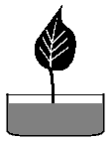
A. The veins in the leaf will turn blue.
B. The leaf will not change at all.
C. The leaf will die because it cannot absorb the water.
D. The veins will dissolve.
Answer: A. The leaf is from a vascular plant, so the vascular "tubes" or veins in the leaf will absorb the colored water.
Students can learn more about plants containing vascular systems by gathering small samples of plant leaves and stems in the back yard and using a magnifying lens to look at the cut section of the stem for the small tube-like structures. To help students understand where the "tubes" are and what they look like, cut the bottom of a celery stalk off, have the student place the cut end into a dish of colored water, and over five days, have them observe the colored "tubes" inside the celery stalk.

