Science Packet

Student Name: ___________________________

Class: ___________________________

Date: ___________________________

Instructions: Read each question carefully and select the correct answer.

1. The diagram below shows evolutionary relationships between dinosaurs. Use the diagram to answer the following question.
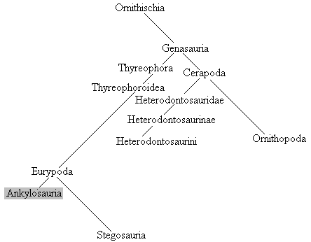
Which of the following is the most distant relative of (least related to) Ankylosauria?
A. Eurypoda
B. Genasauria
C. Stegosauria
D. Ornithischia

2. The diagram below shows evolutionary relationships between dinosaurs. Use the diagram to answer the following question.
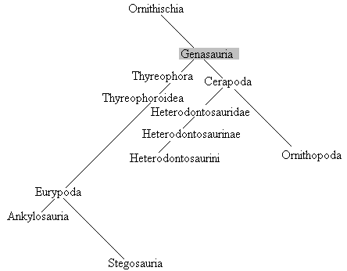
Which of the following is the closest relative of Genasauria?
A. Ornithopoda
B. Ankylosauria
C. Eurypoda
D. Ornithischia

3. Use the diagram below to answer the question.
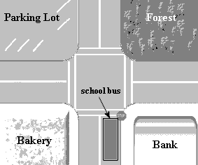
What is most likely the purpose of the diagram?
A. to show the location of the school bus
B. to show what the school bus looks like
C. to show driving directions to the parking lot
D. to show how the bus gets to school

4. The diagram below shows evolutionary relationships between dinosaurs. Use the diagram to answer the following question.
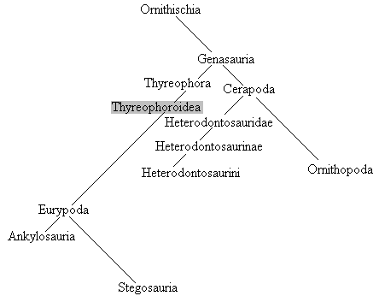
Which of the following is most closely related to Thyreophoroidea?
A. Ornithopoda
B. Stegosauria
C. Thyreophora
D. Heterodontosauridae

5. The chart below shows the distance a herd of gazelle traveled in the span of four days during their migration. Which of the following graphs most accurately represents the information in the chart?
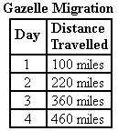
A. 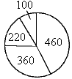
B. 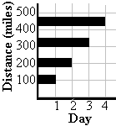
C. 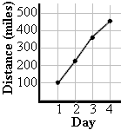
D. 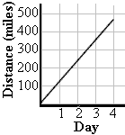

6. The chart below shows the growth of a plant over four days. Which of the following graphs most accurately represents the information in the chart?
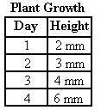
A. 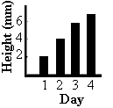
B. 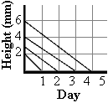
C. 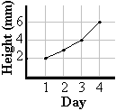
D. 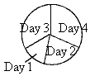

7. The chart below shows the percentages of different types of pets owned by the teachers and students at School # 324. Which of the following graphs most accurately represents the information in the chart?
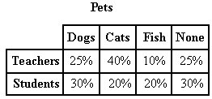
A. 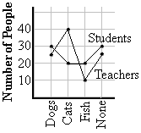
B. 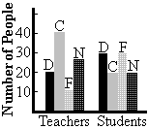
C. 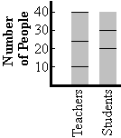
D. 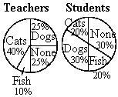

8. One hundred people were surveyed about their favorite colors. Which graph most accurately represents the results in the chart below?
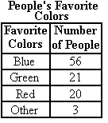
A. 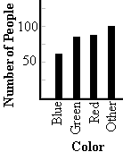
B. 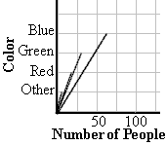
C. 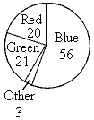
D. 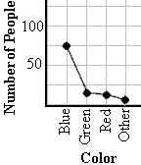

9. The chart below shows a region's weather conditions from 1930 to1999.
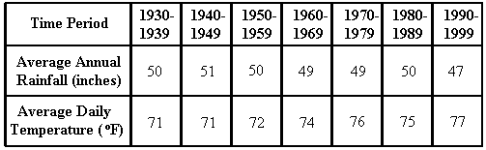
Based on this data, which statement is probably true?
A. Global warming is occurring.
B. Some regions get colder over time.
C. The climate of the area is gradually warming.
D. It will rain more between 2000-2009 than it did from 1990-1999.

10. Three wolf packs were monitored in Timber Woods and the following data was collected.
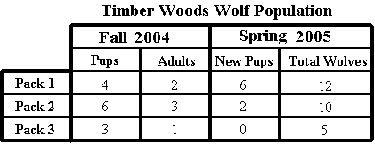
Based on this data, which statement is most likely true?
A. Several wolves from pack 2 did not survive the winter.
B. Pack 1 has the healthiest wolves.
C. A new wolf joined pack 3 during the winter.
D. All of the packs lost some members during the winter.

11. The chart below shows the data from an experiment on mice.
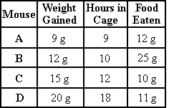
According to the chart, what most likely caused the mice to gain weight?
A. spending more hours inside their cages
B. spending more hours outside their cages
C. eating a lot of food
D. eating little food

12. The chart below shows weather data from four locations in the same city on one day last week.
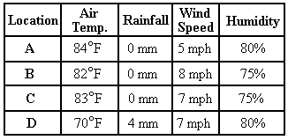
According to the chart, what most likely caused Location D to be cooler than the other locations?
A. the city it is in
B. the wind speed
C. the humidity
D. the rainfall

13. Which of the following is made up of cardiac muscle?
A. the heart
B. the lungs
C. the joints
D. the triceps

14. Where can you find a ball and socket joint?
A. the toes
B. the shoulder
C. the elbow
D. neck

15. Fill in the blank.
The shoulder joint permits movement in all directions. The shoulder is an example of a _______________ joint.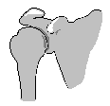
A. hinge
B. ball and socket
C. pivot
D. gliding

16. Which of the following does NOT belong in this group?
pelvis
rib cage
skull
nose
A. pelvis
B. rib cage
C. skull
D. nose

17. Which of the following animals are typically found in wetlands?
A. lions
B. dolphins
C. monkeys
D. alligators

18. Which biome has the largest diversity of plants and animals?
A. grassland (savanna)
B. scrubland (chaparral)
C. tropical rain forest
D. deciduous forests

19. In which biome would you find permafrost?
A. desert
B. grassland
C. rain forest
D. tundra

20. In which biome listed below would you find a cactus growing?
A. tundra
B. tropical rain forest
C. deciduous forest
D. desert

21. Which part of the flower is indicated below?
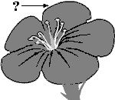
A. ovary
B. petal
C. stamen
D. sepal

22. Which part of the flower is indicated below?
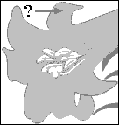
A. petal
B. pistil
C. stamen
D. style

23. Which part of the flower is indicated below?
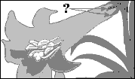
A. stamen
B. style
C. sepal
D. stigma

24. Use this picture of a flower to name the part labeled #2.
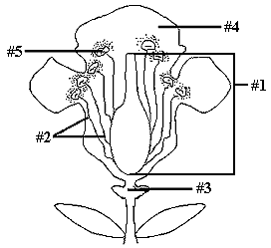
A. filament
B. stamen
C. anther
D. pistil

25. Burrowing owls eat insects and a variety of small animals. They build nests in burrows dug by other animals, such as prairie dogs. Prairie dogs are considered pests and are often killed by farmers. What will probably happen to the owls if the population of these burrowing animals declines?
A. The owls will not be able to find enough nesting sites.
B. The owls will not have enough food.
C. The owls will learn to dig their own burrows.
D. The farmers will start killing the owls.

26. One extremely cold winter, the ground under Hopper Forest froze several feet deep. The next spring, the frog population was significantly lower than the previous year. What was the limiting factor that caused the population to change?
A. soil
B. food
C. temperature
D. water

27. Fill in the blank.
The maximum number of organisms an environment can support is called the __________________.
A. limiting factor
B. carrying capacity
C. biodiversity
D. fertility rate

28. Fill in the blank.
Food, space, temperature, and disease can stop a population from increasing in size. These are known as __________.
A. limiting factors
B. mutual benefits
C. ecological relationships
D. population controls

29. In the carbon cycle, which of the following substances do plants use in order to photosynthesize?
A. carbon
B. oxygen
C. nitrogen
D. carbon dioxide

30. A farmer spreads horse manure over his fields. How does this help his crops?
A. It prevents erosion of topsoil.
B. It holds moisture in the soil.
C. It contains oxygen that plants need.
D. It contains nitrogen that plants need.

31. What human actions influence the nitrogen cycle?
1. using plant fertilizer
2. harvesting crops
3. breathing air
A. 1 and 2 only
B. 1, 2, and 3
C. 3 only
D. 1 and 3 only

32. How might the environment be affected if there were no animals or other organisms to give off carbon dioxide during respiration?
A. More plants would grow because they wouldn't need to waste energy producing oxygen.
B. Plants would die because they need carbon dioxide for photosynthesis.
C. The plants in the area would not be able to reproduce.
D. The plants in the area would die because there would be no more rain.

33. Which cell part is indicated in the cell below?
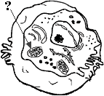
A. vacuole
B. mitochondrion
C. nuclear membrane
D. nucleus

34. Which part of this cell is indicated by the arrow?
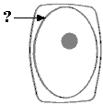
A. cell membrane
B. nucleus
C. cell wall
D. cytoplasm

35. Which part of this cell is indicated by the arrow?
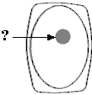
A. cell wall
B. cytoplasm
C. cell membrane
D. nucleus

36. Which of the following numbers indicates the mitochondria of the plant cell below?
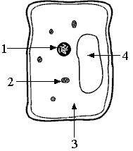
A. 4
B. 1
C. 2
D. 3

37. Fill in the blanks.
During _______________ , _______________ are produced.
A. asexual reproduction; eggs
B. sexual reproduction; spores
C. sexual reproduction; gametes
D. asexual reproduction; sperm

38. Fill in the blank.
The asexual cell division process is called _______________ .
A. symbiosis
B. fertilization
C. meiosis
D. mitosis

39. What is required to begin asexual reproduction?
A. two cells uniting to form one cell
B. one cell splitting into two cells
C. pollination
D. fertilization

40. What is required to begin sexual reproduction?
A. spore formation
B. seed dispersal
C. one cell splitting into two complete cells
D. two cells uniting to form one cell

41. A scientist examined an object under a microscope and observed that it was composed of cells, responds to the environment, and disposes of wastes. What can she determine from these observations?
A. The object is a bacterium.
B. The object is a virus.
C. The object is a living thing.
D. The object is not a living thing.

42. Which of the following are characteristics of all living things?
1. ability to respond to the environment
2. require energy
3. reproduction
4. movement
5. made of a cell or cells
A. 1, 2, 3, 4, and 5
B. 1, 2, 3, and 5
C. 2 and 5
D. 1, 2, and 3

43. Which of the following is an example of how a clam responds to stimuli to protect itself?
A. It filters food from the water.
B. It closes its shell when a predator swims too close.
C. It is composed of many cells.
D. It breathes underwater.

44. Which of the following is NOT a characteristic of all living things?
A. can reproduce
B. responds to the environment
C. grows
D. has blood

45. When a squid feels threatened by seals or other animals swimming by, it changes colors. What is the stimulus in this scenario?
A. the squid changing color
B. the squid's bright coloring
C. seals or other animals swimming by
D. the squid swimming in the ocean

46. Many sea anemones live on the rocky areas around the ocean's edge. When the tide goes out, they are often exposed to the air. If an animal or person touches them, the sea anemones squirt water. What is the stimulus in this scenario?
A. the tide going out
B. sea anemones living on the rocky area by the ocean's edge
C. animals or humans touching the sea anemones
D. the sea anemones squirting water

47. A prairie dog was searching for food when it heard bison coming near. The prairie dog signaled the other prairie dogs in the area to hide underground. What is the stimulus in this scenario?
A. the prairie dogs hiding underground
B. the signal to the other prairie dogs
C. the sound of the bison
D. the prairie dog searching for food

48. Fill in the blank
Behavior is _______________ .
A. learned solely from the environment
B. a response or activity an organism exhibits
C. inherited solely from parents
D. a characteristic of humans only

49. Fill in the blank.
The primary direction of water flow in the xylem is from _______________ of the plant.
A. one side to the other side
B. the top to the bottom
C. the bottom to the top
D. the xylem to the phloem

50. Which of the following tissues has the primary function of transporting water and minerals throughout the plant?
A. xylem
B. parenchyma
C. phloem
D. collenchyma

51. Which of the following is NOT a function of the phloem in vascular plants?
A. sugar transport
B. transpiration
C. water redistribution
D. amino acid transport

52. After the cut end of a flower stem was placed into a glass of red-colored water, the flower's petals changed from white to red. Why did this occur?
A. The plant has a vascular system.
B. The plant is dying.
C. The plant's chloroplasts changed color.
D. The plant's DNA has changed.

