Study Guide
Summer Packet 2

Interpret Box-and-Whisker Plots
Box-and-whisker plots are graphs that are very helpful in interpreting the distribution of data. A box-and-whisker plot is created using five specific numbers from a set of data: the largest number, the smallest number, the median, the first quartile, and the third quartile. These five numbers are called the five number summary of the data.

Definitions:
• The median of a data set is the number that is in the middle of the data set (it separates the data into two equal-sized groups). The median can be found by arranging the numbers in numerical order and finding the middle term.
• The quartiles break the data into four equal-sized groups.
• The first quartile is the median of the lower group of data.
• The second quartile is the median of the entire set of data.
• The third quartile is the median of the upper group of data.
• The interquartile range is the range between the third quartile (Q3) and the first quartile (Q1). It is found using the formula Q3 - Q1.
The box-and-whisker plot below shows how each number is used in the plot.
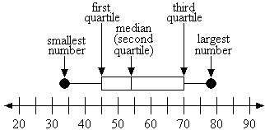
The values of the five number summary for the box-and-whisker plot above are as follows.
smallest number = 34
first quartile = 45
median = 54
third quartile = 70
largest number = 78
interquartile range = 70 - 45 = 25
Box-and-whisker plots can also provide percentages. Since the quartiles break the data into four pieces of equal size, each quartile represents 25% of the data. From the smallest number to the first quartile, 25% of the data is represented. From the smallest number to the median (second quartile), 50% of the data is represented. From the smallest number to the third quartile, 75% of the data is represented. The plot below shows this breakdown.
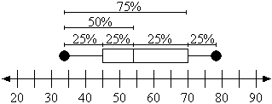
Once the student understands the numbers and percentages that are represented by box-and-whisker plots, he or she can start to answer questions about plots that illustrate real data.
Example 1: The attendance rate for Concerts in the Park this summer is represented in the box-and-whisker plot below. What is the first quartile for this data?
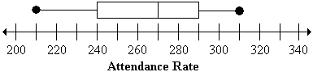
Answer: 240 people
Example 2: The attendance rate for Concerts in the Park this summer is represented in the box-and-whisker plot below. What is the interquartile range for this data?
(1) third quartile = 290
(2) first quartile = 240
(3) 290 - 240 = 50
Step 1: Determine the third quartile for the data set.
Step 2: Determine the first quartile for the data set.
Step 3: Subtract the first quartile from the third quartile.
Answer: 50
Example 3: The attendance rate for Concerts in the Park this summer is represented in the box-and-whisker plot below. What percentage of the concerts had attendance of 290 or higher?
Solution: The question is asking for an attendance rate of 290 or higher. Since 290 is the third quartile, the percentage of the plot that is 290 or higher is 25%.
Answer: 25%

Interpret Stem-and-Leaf Plots
A stem-and-leaf plot summarizes the shape of a set of data (the distribution) and provides extra detail regarding individual values. The data is arranged by place value. The digits with the largest place value are referred to as the stem (stems) and the digits with the smallest place value are referred to as the leaf (leaves). The leaves are always displayed to the right of the stem. A stem can contain one or more digits, but a leaf can only be a one-digit number. Stem-and-leaf plots are generally used for organizing large amounts of information. An example of a stem-and-leaf plot is below.

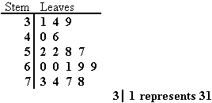
The stems of a stem-and-leaf plot are always listed in numerical order from smallest at the top to largest at the bottom. The leaves of the stem-and-leaf plot are always listed in numerical order from left to right. The stem is read with each leaf. In this case, the stems are the tens place and the leaves are the ones place, so 3 | 1 4 9 represents 31, 34, and 39.
Example 1: What is the maximum value of the data set represented in the stem-and-leaf plot?
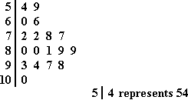
Solution: The largest stem is 10 and the largest leaf for that stem is 0, so the largest number represented by the plot is 100.
Answer: 100
Example 2: The stem-and-leaf plot below shows the test scores from students in Mr. Nguyen's class. In which of the following ranges did most students score?
A. between 50 and 59
B. between 60 and 69
C. between70 and 79
D. between 80 and 89
Solution:
A. is not the correct answer because only 2 students scored between 50 and 59.
B. is not the correct answer because only 2 students scored between 60 and 69.
C. is not the correct answer because only 4 students scored between70 and 79.
D. is the correct answer because 5 students scored between 80 and 89. The next highest range only had 4 students score in it.
Answer: D.
Example 3: The stem-and-leaf plot shows numbers of miles driven while on a vacation by a group of families. How many families drove 235 miles while on vacation?
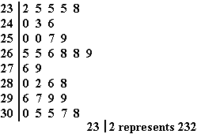
Solution: In this stem-and-leaf plot, the stems represent the hundreds and tens places and the leaves represent the ones place. To figure out how many families drove 235 miles while on vacation, look at the stem of 23 and count the number of 5s listed in the corresponding leaves column. There are 3 leaves that fit these two conditions, so 3 families drove 235 miles while on vacation.
Answer: 3 families
Example 4: The stem-and-leaf plot shows numbers of miles driven while on a vacation by a group of families. How many families drove more than 282 miles while on vacation?
Solution: Look at the stem of 28. There are a total of four numbers represented, but only two of them would be greater than 282. The stem of 29 has another four numbers that would be greater than 282 and the stem of 30 has five numbers that would be greater than 282. So, 2 + 4 + 5 = 11 families drove more than 282 miles while on vacation.
Answer: 11 families
An activity to reinforce this skill is to create a stem-and-leaf plot with the student. Gather data about the ages of family members (from siblings to grandparents) and use the data to create a stem-and-leaf plot together. Then ask the student questions about the stem-and-leaf plot such as the ones below.
• How many people in our family are older than 30?
• Which age occurs the most/least?

Slope
Slope is the ratio of the vertical difference of two points on a line and the horizontal difference between the same two points. Slope is also defined as "rise over run" and is found by calculating the difference in the y-coordinates (rise) divided by the difference in the x-coordinates (run). Slope can be found either graphically or algebraically.

Finding Slope Graphically:
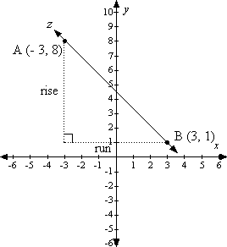
Two points are identified on line z: A (- 3, 8) and B (3, 1).
To find the slope of line z, which passes through points A and B, follow these steps.
Step 1: Start at the left-most point (it is possible to start at either point, but it is important to be consistent), which is point A (- 3, 8).
Step 2: Count up (positive) or down (negative) until level with the right-most point, point B (3, 1). The count will be 7 in the downward direction, or - 7. The rise is - 7.
Step 3: Count right (positive) or left (negative) until point B is reached. The count will be 6 to the right, or +6. The run is 6.
Step 4: Using the "rise over run" definition of slope, place - 7 on top of the fraction and 6 on the bottom of the fraction.
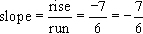
Finding Slope Algebraically:
To find the slope of line z algebraically, follow these steps.
Step 1: Use the formula for the slope of a line, where m is the variable that represents slope.
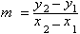
Step 2: 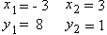
Step 3: Substitute the given coordinate points into the slope formula and simplify the fraction.
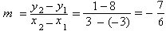
It does not matter which method (graphically or algebraically) is used for determining slope. Regardless, the slope of a line always remains the same.
Example 1: Find the slope of the line between Point R (2, 4) and Point S (1, 3).
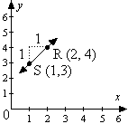
Graphically:
Step 1: Start at the left-most point, which is point S (1, 3).
Step 2: Determine the rise (1).
Step 3: Determine the run (1).
Step 4: Using the "rise over run" definition of slope, place 1 on top of the fraction and 1 on the bottom of the fraction.
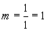
Answer: m = 1
Algebraically:
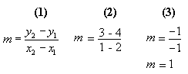
Step 1: Write the formula.
Step 2:
Step 3: Simplify the fraction.
Answer: m = 1
An activity that can reinforce the concept of slope is to have students randomly plot two points on a coordinate system and then find the slope graphically. They can check their answers by substituting the two points into the slope formula.

Equations: Order of Operations
An equation is a statement in which two numbers or two expressions are set equal to each other. For example,
5 + 3 = 8 and 16 = 3c + 4 are equations.

When solving equations, find the value of the variable by getting the variable alone on one side of the equal sign. To do this, undo any operations on the variable by using the inverse operation. Any operation done on one side of the equal sign must be done on the other side of the equal sign in order to keep the statement true.
If a number has been added to the variable, subtract the number from both sides of the equation.
m + 3 = 5
- 3 - 3
m = 2
If a number has been subtracted from the variable, add the number to both sides of the equation.
b - 7 = 9
+ 7 + 7
b = 16
If a variable has been multiplied by a nonzero number, divide both sides by the number.
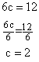
If a variable has been divided by a number, multiply both sides by the number.
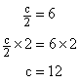
When solving 2-step equations, we must first undo the addition or subtraction using the inverse operation, then undo the multiplication or division:
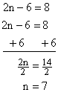
Example 1: Solve the equation for t.
5(t - 4) = t + 12
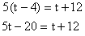
Step 1: Multiply 5 times the terms inside the parenthesis.
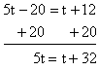
Step 2: Add 20 to both sides of the equation
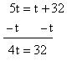
Step 3: Subtract t from both sides of the equation
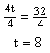
Step 4: Divide both sides of the equation by 4.
Answer: t = 8
Example 2: Evaluate the expression for c = 3:
2(c + 4) + 2(15)
(1) 2(3 + 4) + 2(15)
(2) 2(7) + 2(15)
(3) 14 + 30
(4) 44
Step 1: Substitute 3 in place of 'c' in the expression.
Step 2: Add the numbers in parentheses.
Step 3: Rewrite the equation after performing all multiplications in order from left to right.
Step 4: Add 14 and 30 to get 44.
Answer: 44

Area of Rectangle - A
Area is the measurement of the interior of a two-dimensional region. Area measurements are in square units.

The formula for calculating area of a square or rectangle is: Area = length x width.
Example 1: A figure has a width of 7 inches and a length of 3 inches. What is the area of the figure?
Step 1: Multiply the width and the length.
Area = 7 x 3 = 21
Answer: 21 square inches
It may be useful to use graph paper to develop figures. Help the student determine the area of various figures drawn on the graph paper.

Multiple-step Story Problems - B
Multiple-step story problems test a student's ability to interpret data from a written word problem. Answers are found by solving equations with multiple operations.

It may be helpful to develop a series of multiple-step word problems that relate to the student's activities, such as allowance or sports. The following is a step-by-step example of a multiple step story problem.
Solve: On Saturday, Stella earned $3.50 for each hour of work. She earned $3.25 for each hour of work on Sunday. She worked 5 hours each day. How much money did she earn for both days?
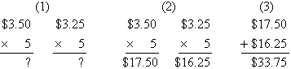
Step 1: Develop 2 separate equations. One to find the earnings on Saturday, and one to find the earnings on Sunday.
Step 2: Find the products of the two equations.
Step 3: Add the two products together.
Answer: Stella earned $33.75.

Equations With Two Variables
This study guide will focus on solving equations that contain two variables.

Remember:
Variables are letters or symbols that represent numbers that are unknown.
Expressions are variables or combinations of variables, numbers, and symbols that represent a mathematical relationship. Expressions do not have equal signs, but can be evaluated or simplified.
Example: y - 9
Equations are expressions that contain equal signs. They can be solved, but not evaluated.
Example: 5 + x = 13
Like terms are those terms that have the same variable(s) in common, or no variable. Like terms can be combined.
Examples: 2 and 3 are like terms, 2x and 3x are like terms, but 2 and 3x are not like terms.
Solving Equations
To solve an equation, it is necessary to "undo" what was done to the variable in question. Another way to think about this is to do the order of operations in reverse.
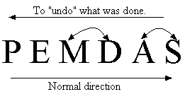
P = Parenthesis, E = Exponents, M = Multiplication, D = Division, A = Addition, S = Subtraction.
**In the normal direction, first evaluate multiplication and division from left to right (whichever comes first), then evaluate addition and subtraction from left to right (whichever comes first).
**To "undo" what was done, reverse the direction.
•Addition "undoes" subtraction.
•Subtraction "undoes" addition.
•Multiplication "undoes" division.
•Division "undoes" multiplication.
Addition/Subtraction Properties - Adding or subtracting the same real number to each side of an equation will result in an equivalent equation.
Example 1: Solve 16 = 5 + x - 8 for x.
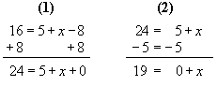
Step 1: Begin to isolate the variable, x, by adding 8 to both sides of the equation. Remember to only add and subtract like terms, so the 8 must be added to the - 8 and the 16.
Step 2: Subtract 5 from both sides of the equation to completely isolate the variable, x.
Answer: x = 19
Multiplication/Division Properties - Multiplying or dividing each side of an equation by the same (nonzero) number will result in an equivalent equation.
Example 2: Solve the following equation for t.
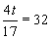
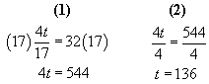
Step 1: Multiply both sides of the equation by 17 to eliminate the fraction.
Step 2: Divide both sides of the equation by 4 to isolate the variable, t.
Answer: t =136.
Solving Equations With Two Variables
In order to solve equations that contain two variables, the student will need to solve for one variable in terms of the other. This means that the answer may not be entirely numeric.
The same properties as described above should be used when solving for a given variable in a two-variable equation. Students should treat the second variable as if it were a number.
Example 3: Solve 30w - 9v = 6 for w.
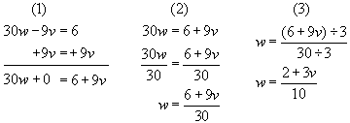
Step 1: Begin to isolate w by adding 9v to both sides of the equation. Remember to only combine like terms.
Step 2: Completely isolate the variable, w, by dividing by 30 on both sides of the equation.
Step 3: Simplify the solution. Since 6, 9, and 30 can all be divided by 3, divide the numerator and denominator of the fraction by 3.
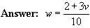
Example 4: Solve the following equation for r.
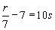
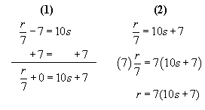
Step 1: Begin to isolate r by adding 7 to both sides of the equation. Remember to only combine like terms. 10s + 7 cannot be combined because they are not like terms.
Step 2: Completely isolate r by multiplying both sides of the equation by 7.
Answer: r = 7(10s +7)
Example 5: Solve the following equation for a.
5(a - b) = 14b
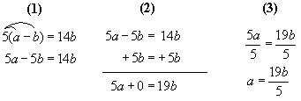
Step 1: Questions of this type involve using the distributive property. The distributive property states that for all numbers a, b, and c, a(b + c) = ab + ac. Therefore, begin by multiplying 5 by a and by b.
Step 2: Next, begin to isolate a by adding 5b to both sides of the equation. 14b and 5b are considered like terms so they can be added together to get 19b.
Step 3: Completely isolate the variable, a, by dividing both sides of the equation by 5.
Example 6: Solve the following equation for x.
8xy - 9x = 20
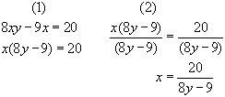
Step 1: Questions of this type involve using the distributive property to write x as a factor. Begin by factoring out the x as a common factor.
Step 2: Isolate the variable, x, by dividing both sides of the equation by (8y - 9).
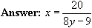

Add Decimals: Story Problems - C
Story problems, also called word problems, relate addition of decimal numbers to actual situations. Operational symbols, such as the addition (+) symbol, are replaced with text. Word problems in this skill also deal with money.

Story problems are often very difficult for students to master. It may be beneficial for you to create problems that students can easily relate to, and help the student determine the correct formulas.
Example: Fred ran 8.971 miles on Saturday and 5.363 miles on Sunday. How many miles did Fred run in all?
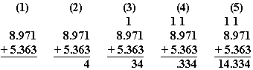
Step 1: Identify the equation and remember to line up the decimal points.
Step 2: Add the numbers in the thousandths position (1 + 3 = 4). Write the 4 in the thousandths position below the line.
Step 3: Add the numbers in the hundredths position (7 + 6 = 13). Write the 3 in the hundredths position below the line. Carry the 1 to the next column (tenths).
Step 4: Add the numbers in the tenths column, including the number carried over from the previous column (9 + 3 + 1 = 13). Write the 3 in the tenths position (below the line). Carry the 1 to the next column (ones). Bring the decimal point down.
Step 5: Add the numbers in the ones position, including the number carried over from the previous column (8 + 5 + 1 = 14). Write the 14 to the left of the decimal point (below the line).
Answer: Fred ran 14.334 miles.

Divide Decimals
Dividing a decimal number by another decimal number requires repositioning the decimal point so that it does not appear in the divisor.

The following is a step-by-step example of a decimal number divided by a decimal number.
Solve: 17.28 divided by 3.2 = ?
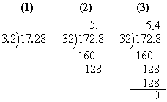
Step 1: Write the problem in long division format.
Step 2: There is a decimal point in the divisor. Multiply the dividend and the divisor by 10, thus moving the decimal point one place to the right. Then, place the decimal point directly above the decimal point in the dividend.
Step 3: Division follows the same format as with whole numbers. 32 goes into 172 five times because 32 x 5 = 160. Place 5 in the ones position. Subtract 160 from 172 resulting in 12. Bring down the 8.
Step 4: 32 goes into 128 four times because 32 x 4 = 128. Place 4 in the tenths position. Subtract 128 from 128 resulting in zero.
The correct answer for 17.28 divided by 3.2 is 5.4.

Circle Graphs - A
A graph is a drawing used to show and compare information. A circle graph, or pie chart, is often used to show parts of a whole.

An interesting method for increasing the student's understanding of graphs is to help him or her develop a graph for a school project or event.
Have him or her create a circle graph for the events that typically occur in the student's day. If he or she spends half of the day at school, then half (1/2) of the circle would be filled with the title "School." Similarly, if one-quarter (1/4) of the day is spent at the soccer field, then a quarter of the pie would be titled "Soccer." The following is an example:
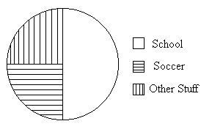
Example 1: Callie wanted to show how she spent her time. She made a pie graph of her typical 24 hour day. Use the pie graph to answer the question.
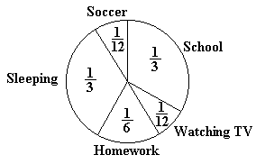
How many hours does Callie spend in school?
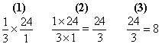
Step 1: Callie spends 1/3 of her day in school, so we need to multiply 1/3 by 24 hours to determine the number of hours Callie spends in school.
Step 2: Multiply the numerators (top numbers) together (1 x 24 = 24) and multiply the denominators (bottom numbers) together (3 x 1 = 3).
Step 3: Divide 24 by 3 to determine the number of hours Callie spends in school each day.
Answer: Callie spends 8 hours in school each day.

Add Fractions: Mixed Numbers - A
Adding mixed fractions requires a solid understanding of adding fractions and the multiplication table. If the numerator of a fraction is less than the denominator, the fraction is called a proper fraction. If the numerator is equal to or greater than the denominator, the fraction is called an improper fraction. An improper fraction can be rewritten as a mixed fraction. For example, 5/3 is an improper fraction. It can be rewritten as 1 2/3, which is a mixed fraction.

The following is a step-by-step example of adding two mixed fractions with different denominators.
Example 1: Reduce all fractions to lowest terms.
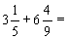
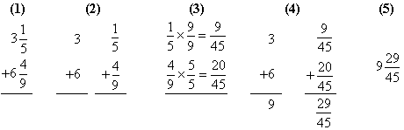Step 1: Rewrite horizontal problems vertically. (This step is not necessary, but many students find it easier to add fractions when the problems are written vertically.)
Step 2: Separate the problem into addition of whole numbers and addition of fractions.
Step 3: Find a common denominator (a common multiple of the denominators of two or more fractions) for the fractions. The common denominator is 45 (because both 5 and 9 will divide into 45). Multiply 1/5 by 9/9. Multiply 4/9 by 5/5.
Step 4: Add the whole numbers (3 + 6 = 9). Add the numerators (9 + 20 = 29). The denominator remains the same (45).
Step 5: Combine the whole number and fraction to produce the answer.
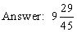
It may be necessary to reduce a fraction that is part of an answer. A fraction is in lowest terms when the numerator and denominator do not have a common factor greater than one. To reduce a fraction, determine the largest number that the numerator and the denominator can both be divided by and divide them by that number.
Example 2: Reduce all fractions to lowest terms.
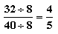
Solution: The largest number 32 and 40 can both be divided by is 8. Divide 32 by 8 and divide 40 by 8.
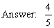

Divide Fractions
Dividing fractions requires a strong knowledge of multiplication of fractions.

The following is a step-by-step example of dividing fractions.
Example 1: Reduce answer to lowest terms.
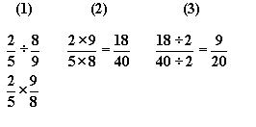
Step 1: Rewrite the problem as a multiplication problem. There is a rhyme to help remember how to complete this process:
Dividing fractions is easy as pie,
Flip the second and multiply.
Using this rhyme, the second fraction (8/9) becomes 9/8, and the ÷ symbol becomes a x symbol.
Step 2: Multiply the numerators (2 x 9 = 18) and the denominators (5 x 8 = 40).
Step 3: Reduce the fraction to lowest terms. A fraction is in lowest terms when the numerator and denominator do not have a common factor greater than one. Eighteen and 40 can both be divided by 2, so complete this division to reduce the fraction.

Rounding and Estimation - C
Rounding and estimation are used to express a number to the nearest ten, hundred, thousand, and so forth.

An interesting method for improving the student's rounding and estimation skills is to create a list of numbers. Help the student round each number. Remember, numbers less than 5 are rounded down, while numbers 5 or greater are rounded up (in both cases, you are looking one place to the right of the place value you wish to round).
34 rounded to the nearest ten is 30.
37 rounded to the nearest ten is 40.
In order to round decimal numbers to whole numbers, we look at the digit in the tenths place. If the digit is less than 5, drop the decimal part. If the digit is 5 or more, drop the decimal part and round up.
Example 1:
7.328 rounded to the nearest whole number is 7
8.74 rounded to the nearest whole number is 9
In estimating an answer, we round the numbers we are operating with in order to determine a simpler answer. The examples below illustrate this process.
Example 2: Which of the following formulas should be used to estimate 36.3 x 8.9?
A. 37 x 8
B. 37 x 9
C. 36 x 9
D. 36 x 8
Solution: Round both numbers to the nearest whole number.
36.3 rounds to 36
8.9 rounds to 9
The answer is C.
Example 3: Which of the following formulas should you use to estimate 7,849 x 3,434?
A. 7,000 x 3000
B. 7,000 x 4000
C. 8,000 x 3,000
D. 8,000 x 4000
Solution: We round both numbers to the nearest thousand.
7,849 rounds to 8,000
3,434 rounds to 3,000
The answer is C.

Adding Integers
Integers are the set of positive and negative whole numbers, including zero. To add integers, students must understand how integers appear on a number line. Numbers to the right of 0 on a number line are positive and numbers to the left of 0 are negative. The number -3 is a negative integer and the number 3 is a positive integer. The number zero is neither positive nor negative, it is neutral.

It may be beneficial to verify that the student understands integers by having him or her create a number line. Label points to the left of 0 "negative," and points to the right of the 0 "positive." The following is an example of a number line:
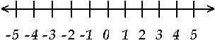
Confirm that the student understands that -4 is less than 4. Once he or she is comfortable with the concept of integers, introduce adding and subtracting. For example, -4 + 2. Start at -4 and move 2 places to the right (because we are adding). The answer is -2.
When adding two integers with the same sign, add their absolute values. Then give the sum (answer) the sign of the integers.
-3 + -2 = ?
|-3| + |-2| = ?
3 +2 = 5, then make the result negative.
Answer: -5
When adding integers with different signs, first find their absolute values. Then subtract the lesser absolute value from the greater absolute value, and give the result the sign of the integer with the greater absolute value.
-7 + 3 = ?
|-7| = 7 and |3| = 3 (find the absolute values)
7 - 3 = ? (subtract the lesser from the greater)
7 - 3 = 4
-7 + 3 = -4 (The result is given the sign of the greater integer.)

Area of Parallelogram - A
The area of a parallelogram is the number of square units needed to cover the surface of the figure.

To find the area of a parallelogram, multiply the base(b) by the height(h). The base is the length of the top or the bottom of the figure. The height is the length of a line going from the base at a right angle to the opposite side. Here is the formula:
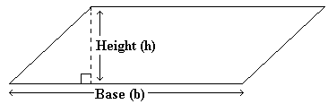
Area of a parallelogram = (base) x (height)
Example 1: Find the area of a parallelogram with a base equal to 5 feet and a height equal to 2 feet?
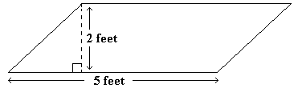
Area = 5 feet x 2 feet = 10 square feet
Answer: 10 square feet
Example 2: What is the value of N?
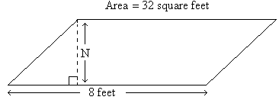
(1) 32 = 8 x N
(2) 4 = N
Step 1: Substitute the known values into the formula for the area of a parallelogram.
Step 2: Divide each side of the equation by 8. (32 ÷ 8 = 4 and 8 ÷ 8 = 1
Answer: 4 feet

Radicals and Roots
Mastering roots and radicals is an essential step toward learning advanced mathematics concepts. A radical sign looks like a check mark with a line attached to the top. The radical sign is used to communicate square roots.

The following rules are required to perform operations with roots and radicals.
1. If x multiplied by x equals y, then x is a square root of y. For example, 6 multiplied by 6 is 36, so 6 is a square root of 36. In fact, 36 is called a perfect square because its square root, 6, is a whole number. Most algebra text books contain a table of perfect squares.
2. -3 and 3 are both square roots of 9 because -3 x -3 = 9 and 3 x 3 = 9. 3 is referred to as the principal square root because it is the positive square root of 9.
3. To find the simplest radical form of a radical expression, factor the number under the radical sign (the radicand). The square root of 45 could be factored to be the square root of 9 multiplied by the square root of 5. The square root of 9 multiplied by the square root of 5 can be simplified further by finding the square root of 9. The result is 3 (the square root of 9) multiplied by the square root of 5.
Example 1: Find the equivalent form.
Solution: Multiply the numbers under the radical symbols.
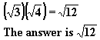
Example 2: What symbol would best replace the ? in the given statement?
A. =
B. <
C. >
There are two methods that can be used to solve this problem. Each method is shown and explained below.
Solution Method 1:
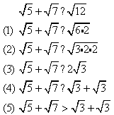
Step 1: Simplify the square root of 12 by making it the square root of 6 x 2.
Step 2: Further simplify the square root of 6 x 2 by making it the square root of 3 x 2 x 2. (If you multiply 3 x 2 x 2, you will get 12.)
Step 3: The square root of 3 x 2 x 2 becomes 2 times the square root of 3, because the square root of 2 x 2 is 2 and the 3 must remain under the square root symbol.
Step 4: Two times the square root of 3 can also be written as the square root of 3 plus the square root of 3.
Step 5: Now, we can make a comparison. We know that the larger a number is, the larger that number's square root will be. We can determine that the square root of 5 plus the square root of 7 will be greater than the square root of 3 plus the square root of 3 because 5 and 7 are both larger than 3.
Answer: C
Solution Method 2:
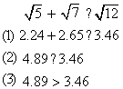
Step 1: Estimate the square root of 5, the square root of 7, and the square root of 12. This estimation can be done using a calculator.
Step 2: Add together the 2.24 and the 2.65 to get 4.89.
Step 3: Replace the question mark with the > symbol because 4.89 is greater than 3.46.
Answer: C
Example 3: Solve for the value of x.
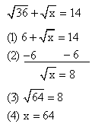
Step 1: The square root of 36 is 6 because 6 x 6 = 36.
Step 2: Subtract 6 from each side of the equation to isolate the square root of x.
Step 3: The square root of x is equal to 8. We can replace the x with 64, since the square root of 64 is 8.
Step 4: Since the square root of 64 equals 8, the value of x is 64.
Answer: x = 64

Area of Circle
The area of a circle is the number of square units needed to cover the surface of the figure.

The following is the formula needed for calculating the area of a circle:
Pi is approximately equal to 3.14. The symbol for Pi is The radius is the length from the center of the circle to the outside edge. The diameter is the line segment that connects two points on the outside edge of the circle and passes through the center of the circle. The length of the diameter is twice the length of the radius.
Example 1: Solve for the area of a circle with a radius equal to 4 meters.
(1) Area = 3.14 x (4 x 4)
(2) Area = 3.14 x 16
(3) Area = 50.24
Step 1: Apply the amounts given in the problem to the formula.
Step 2: Multiply the numbers within the parentheses.
Step 3: Perform calculations to find the answer.
A semicircle is half of a circle. The area of a semicircle is exactly half of the area of a circle with the same radius.
Example 2: What is the area of the following semicircle? Round your answer to the nearest hundredth.
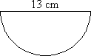
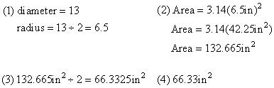
Step 1: The diameter of the semicircle is 13 inches, so the radius is 13 inches divided by 2 (6.5 inches).
Step 2: Determine the area of a circle with radius 6.5 inches.
Step 3: Divide the area of the circle by 2 to find the area of the semicircle with radius 6.5 inches.
Step 4: Round 66.3325 to the nearest hundredth.
The area of the semicircle is 66.33 square inches.

Data Analysis
Data collected from an experiment or from a survey is difficult to analyze in its raw form. When any data is organized and presented in graphical form, it is much easier to interpret. Trends can be more easily noted such as "Have the company's sales increased or decreased over the past year?" Questions can more easily and quickly be answered such as "Which class sold the most candy bars for a fundraiser?" The types of graphs used to present data that will be discussed in this presentation include: line graph, bar graph, and circle graph (or pie chart).

Line Graphs:
To create a line graph, data points are plotted on an x-y coordinate graph. To make the data easier to read and analyze, the data points are then connected to form the line graph. Note that points on the segments used to connect the dots do not represent actual data points, they are included to help point out a possible trend in the collected data. Line graphs can be used to show the trends of groups of data, as the following example demonstrates. The line graph compares Marc's weight with his age. A quick glance at the graph shows that he gained weight at a quicker pace while he was very young and that his weight has gradually increased over the last few years with the exception of age 6.
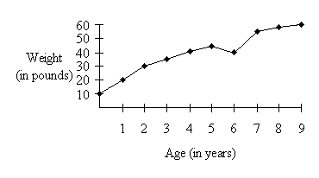
Line graphs can be used to compare the trends of two groups of data. To differentiate between the two groups of data, solid and dotted lines are used.
Example 1: The following graph shows the population of two different cities over a 50 year period. In what year did City A have its greatest population?
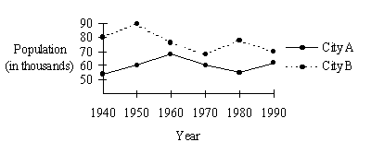
City A, which is shown by the solid line, had its greatest population in 1960 because the graph reaches its highest point at the 1960 marking.
Bar Graphs:
A bar graph is created to present data that can be represented by ordered pairs. The bar or rectangle is used to represent one member of the ordered pair. The height or length of the bar is determined by the second member of the ordered pair. The following bar graph compares the number of correct answers scored on each question of a test. The bar is determined by the question number and the height is determined by the number of correct answers for a particular question. A quick glance at this graph can help the teacher determine that question 5 on this test reflected a great deal of difficulty for the students.
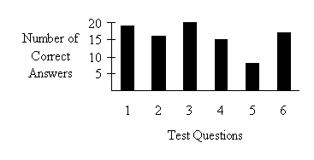
Bar graphs can be used to compare the trends of two groups of data. To differentiate between the two groups of data, the "bars" can have different colors or markings.
Example 2: The following graph shows the population of two different cities over a 50 year period. In what year did City B have its greatest population?
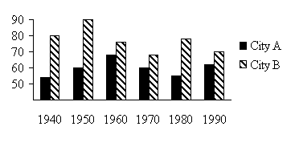
City B, represented by the bars filled with diagonal lines, had its greatest population in 1950 because the bar graph hits its peak at the 1950 marking.
Circle Graphs:
Circle graphs or pie charts group the data into a circle that has been subdivided into parts, often labeled by fractions or percents. The whole circle represents a general category, such as in the following example which represents a store's monthly expenses. The circle is divided into as many sections as there are different types of expenses. The circle graph represents a total of 100%
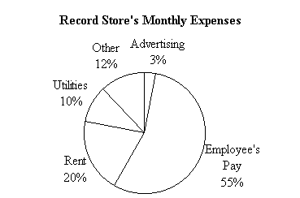
From the chart it is easy to read that the greatest expense per month for the store is the payment of employees' salaries.
Example 3: The following is a graph showing the money earned by the senior class fund raisers. What percent was earned by selling hot dogs and sodas at the football games?
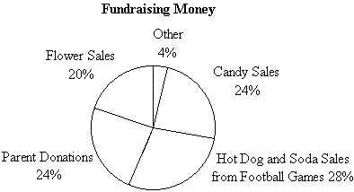
The circle graph indicates that 28% of the total money raised was earned by selling hot dogs and sodas at the football game.

Non-Linear Equations
A non-linear equation is an equation whose graph is not a straight line.

An example of a linear equation (graph is a straight line) is y = x + 3 and an example of a non-linear equation is These two equations are graphed below.
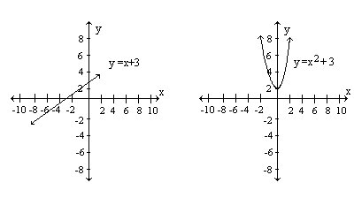
A basic rule to follow to determine whether an equation is linear or non-linear is that non-linear equations have variables that have powers other than one and linear equations have powers equal only to one.
Simplifying Square Roots:
Before we can begin solving non-linear equations, we must discuss how to simplify square roots. When a number is multiplied by itself the product is the square of the number. A square root of a number is a factor that when multiplied by itself equals the number. For example: 2 x 2 = 4, so 4 is the square of 2 also, since 4 = 2 x 2, 2 is a square root of 4. Another square root of 4 is -2 because -2 x -2 = 4. Numbers that have a rational number as their square root are called perfect squares. Examples of perfect squares are: 9 (square root is 3), 16 (square root is 4), 25 (square root is 5) and 9/25 (square root is 3/5).
The notation for a square root is this symbol:
To simplify a square root, we first determine two factors that multiply to make the whole number. One of these two factors should be a perfect square, preferably the largest perfect square that is a factor of the number. Then we take the square root of the perfect square factor and place that number in front of the radical symbol.
Example 1: Simplify.
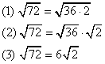
Step 1: Rewrite the problem as the square root of two factors of 72. Remember, one of the factors should be the largest perfect square that is a factor of 72. In this case 36 and 2 were used because 36 times 2 equals 72 and 36 is a perfect square.
Step 2: Now the problem can be rewritten as the square root of 36 times the square root of 2.
Step 3: Determine the square root of 36 (which is 6) and multiply it by radical 2. Since 2 does not have a factor that is a perfect square, radical 2 does not change.
Example 2: Another way to simplify
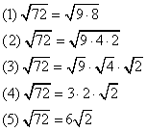
Step 1: It is possible to simplify a square root if the largest perfect square factor is not known. Once again, rewrite the problem as the square root of two factors of 72. Make sure one of these two factors is a perfect square. In this case 9 and 8 were used because 9 is a perfect square and 9 times 8 equals 72.
Step 2: Since 8 has a factor that is a perfect square (4), the problem must be rewritten as the product of these three factors of 72. 9 x 4 x 2 = 72.
Step 3: Since 9 and 4 are perfect squares and 2 does not have a perfect square factor, the problem can be rewritten as the square root of 9 times the square root of 4 times the square root of 2.
Step 4: Determine the square root of 9 (which is 3), multiply it by the square root of 4 (which is 2), and multiply them both by radical 2.
Step 5: Finally, multiply 3 and 2 to get 6. The 6 is multiplied by radical 2 to obtain the final answer:
Solving Non-Linear Equations:
Non-Linear equations can be solved in much the same way as linear equations. The goal of solving a non-linear equation is to isolate the variable on one side of the equal sign.
Example 3: Solve the following equation.
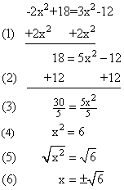
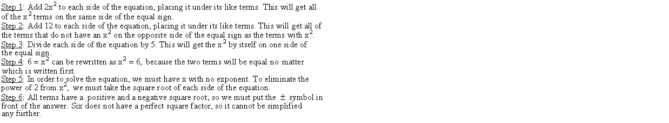
Answer:
Example 4: Solve the following equation.
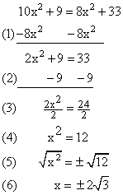
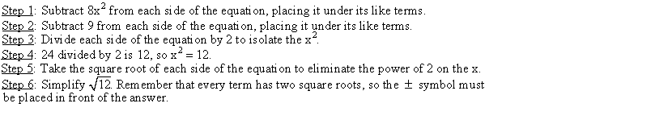
Using the Pythagorean Theorem to Solve Non-Linear Equations:
The Pythagorean Theorem can be used to determine the length of a missing side of a right triangle. A right triangle is a triangle that has one right (90º ) angle. A 90º angle is marked in a triangle with a box in the angle. The Pythagorean Theorem states that the sum of the squares of the legs of a right triangle is equal to the square of the hypotenuse. The hypotenuse of a right triangle is the side of the triangle opposite the right angle. The other two sides of the triangle are called the legs.
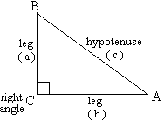
The Pythagorean Theorem states:
In the Pythagorean Theorem, 'c' represents the length of the hypotenuse and 'a' and 'b' represent the lengths of the legs of the right triangle. The Pythagorean Theorem only works for right triangles.
Example 5: Use the Pythagorean Theorem to solve for x.
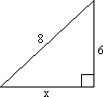
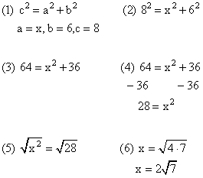
Step 1: Write the Pythagorean Theorem. Then determine the values of a, b, and c. Remember, c always represents the length of the hypotenuse. In this triangle, the length of the hypotenuse is 8, so c = 8. It does not matter whether a or b is assigned the value of x or the value of 6.
Step 2: Substitute the values of a, b, and c into the Pythagorean Theorem.
Step 3: Following the order of operations, square the 8 (8 x 8 = 64) and the 6 (6 x 6 = 36).
Step 4: Subtract 36 from each side of the equation.
Step 5: Take the square root of each side of the equation.
Step 6: Simplify radical 28. In this case, the variable represents the length of the side of a triangle, so the answer cannot be negative.
Answer:
Solving an Equation by Completing the Square:
Completing the square is a method of solving a quadratic equation in order to express the equation as a single squared term. The method of completing the square is used when an equation cannot be factored. Completing the square involves adding the square of one term to the equation and solving the equation for the value of the variable. The theorem for completing the square states:
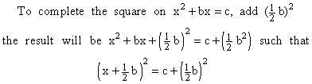
The following is a detailed example of how to complete the square.
Example 6: Solve the equation by completing the square.
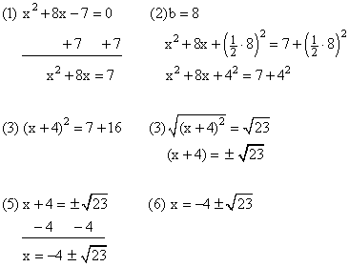
Step 1: Add 7 to each side of the equation to put the equation in the form Step 2: Since 8 is in the same place as b, b = 8. Add the square of 1/2 of b to each side of the equation. One-half of 8 equals 4, so we are actually adding 4 squared to each side of the equation.
Step 3: We need to fill in the final form in the theorem for completing the square. One-half of b equals 4, so inside the parentheses we have (x + 4). Then we place an exponent of 2 outside the parentheses. Finally, 4 squared equals 16 (4 x 4).
Step 4: First, add 7 and 16 to get 23. Then take the square root of each side of the equation. Taking the square root of a term is the opposite of squaring a term, so we get x + 4 on one side of the equal sign. Remember, every number has a positive and a negative square root, so we write Step 5: Subtract 4 from each side of the equation to isolate the x on one side of the equal sign. The new expression cannot be simplified.
Step 6: The solution to the equation is
Characteristics that Describe the Graph of a Non-Linear Equation:
A quadratic equation is any equation in the form The graph of a quadratic equation is always a parabola. The vertex of a parabola can be found by putting the quadratic equation in vertex form.
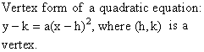
Once a quadratic equation is in vertex form, the vertex is the coordinate point (h, k). If a > 0, then the graph opens up and has a minimum. If a < 0, then the graph opens down and has a maximum.
The roots of a quadratic equation are the solutions of the quadratic equation when y = 0. The roots are the points where the graph intersects the x-axis; therefore, y = 0. The axis of symmetry is the line that passes through the vertex and splits the graph directly in half such that each side is the mirror image of the other. This line is represented by the equation x = h.
Example 7: What are the characteristics of the graph of
Step 1: Rewrite the equation in vertex form. The simplest way to do this is by completing the square.
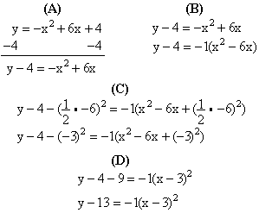
Step 1A: Subtract 4 from each side of the equation.
Step 1B: Factor -1 out of the right side of the equation to make the term positive.
Step 1C: Add 1/2 of the b term (-6) squared to the right side of the equation and subtract 1/2 of the b term from the left side of the equation (we subtract on the left side of the equation because we factored -1 out of the equation in Step 1B and we need to multiply any number by -1 before we can add or subtract it from the left side of the equation). b = -6, so we are actually adding -3 squared to the right side of the equation and subtracting -3 squared from the left side of the equation.
Step 1D: Complete the theorem for completing the square.
Step 2: Determine whether the graph opens up or down. Now that the equation is in vertex form, we can determine that a = -1. Since a < 0, the graph opens down.
Step 3: Determine the vertex of the parabola. The vertex is the point (h, k). h = 3 and k = 13, so the vertex is (3, 13).
Step 4: Determine the axis of symmetry. The axis of symmetry is the line x = h. The axis of symmetry is x = 3.
Step 5: Determine the roots of the equation. The roots of the equation are the values of x when y = 0.
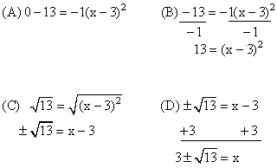
Step 5A: Substitute 0 in place of y.
Step 5B: Divide each side of the equation by -1.
Step 5C: Take the square root of each side of the equation.
Step 5D: The roots of the equation are 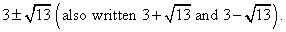
If the 13 had been negative, the equation would have had no real roots.
(1) opens down
(2) vertex is (3, 13)
(3) axis of symmetry is: x = 3
(4) roots are

Dividing Integers
Integers are the set of positive and negative whole numbers, including zero. To find the quotient (answer to a division problem) of two integers, the following rules apply:
The quotient of two integers with different signs is negative. Example: 16 ÷ -4 = -4.
The quotient of two integers with the same sign is positive. Examples: 16 ÷ 4 = 4 and -16 ÷ -4 = 4.

Operations within parentheses are completed first. After performing operations within parentheses, perform all multiplication and division in order from left to right. The last step is to perform all addition and subtraction in order from left to right. (It may be helpful here to review order of operations and/or multiplying with integers.)
Example 1: 4(-3 x 2) ÷ (12 ÷ 2) = ?
(1) -3 x 2 = -6 and 12 ÷ 2 = 6
(2) 4(-6) ÷ 6 = ?
(3) -24 ÷ 6 = ?
(4) -24 ÷ 6 = -4
Step 1: Perform operations within parentheses: ( -3 x 2 = -6) and (12 ÷ 2 = 6).
Step 2: Write out the problem, replacing the values within the parentheses with the new values.
Step 3: Perform multiplication or division in order from left to right. Multiply first because it comes first when reading from left to right. 4(-6) = -24.
Step 4: Divide -24 by 6 to get -4. Remember the quotient of two integers with different signs is negative.
Answer: -4
The following example illustrates the use of rules for dividing integers using "is greater than" (>) and "is less than" (<).
Example 2: -24 ? 3(10 ÷ -2)
(1) 10 ÷ -2 = -5
(2) -24 ? 3(-5)
(3) 3 x -5 = -15
(4) -24 ? -15
(5) -24 < -15
Step 1: Perform operations within parentheses. 10 ÷ -2 = -5.
Step 2: Rewrite the problem with -5 in place of the parentheses.
Step 3: Multiply 3 x -5 to get -15.
Step 4: Rewrite the problem with -15 in place of 3(-5).
Step 5: To determine which symbol to place between -24 and -15, think of the integers as being money. -24 would be like owing someone $24 and -15 would be like owing someone $15. Since owing $24 is more in debt than owing $15, -24 is less than -15.
Answer: -24 < -15

Equations: Addition/Subtraction
Equations are number sentences which contain equal signs.
Example: n + 5 = 9
Expressions are number sentences which do not have equal signs, but need to be evaluated or simplified.
Example: y - 6
Variables are letters or symbols that represent numbers that are unknown.

The following are examples of how to solve equations.
Example 1: Solve: n + 6 = 20
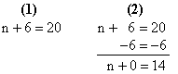
Step 1: Write the equation.
Step 2: Subtract 6 from both sides of the equation.
Answer: n = 14
Example 2: Solve for x.
16.6 = 5.5 + x - 8.2
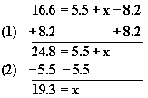
Step 1: Begin to isolate the variable on one side of the equation by adding 8.2 to both sides.
Step 2: Subtract 5.5 from both sides to completely isolate the variable.
Answer: x = 19.3

Equations: Multiplication/Division
Equations are number sentences which contain equal signs:
Example: n + 5 = 9
Expressions are number sentences which do not have equal signs, but need to be evaluated or simplified:
Example: y - 6

A common mistake among students first learning to multiply and divide equations is the failure to use inverse operations. For instance, in the equation 3x = 8, the student might multiply 3 to both sides of the equal sign. The correct procedure is to use the inverse operation and divide 3 from both sides (x = 8/3). By applying the inverse operation, the student can isolate the x.
Example 1: Solve: 5n = 75
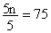
Step 1: In the equation, solve for the value of n.
Step 2: 5n is the same as 5 x n. Divide both sides of the equation by 5.
Step 3: 75 ÷ 5 = 15
Answer: n = 15
Example 2: Solve for t.
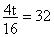 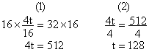
Step 1: Multiply both sides of the equation by 16 to eliminate the fraction.
Step 2: Divide both sides if the equation by 4 to isolate the variable t.
Answer: t = 128.

Solving Equations: Substitution
Letters expressing unknown values in equations are called variables. In these two variable equations, students are given the value of one variable. To find the value of the second variable, substitution must be used.

If y = 4x, and x = 9, substitute the given value of x, in the equation, y = 4x. The result is y = 4(9). Calculate the right side of the equation to get y = 36. Now the values of both variables are known: x = 9 and y = 36.
To check the answer, set up the equation y = 4x as if x was an unknown variable: 36 = 4x. Divide each side of the equation by 4. The result is x = 9, so the values for x and y are both correct.
Example 1: Solve for x.
x = 3y + 9
y = -2
Solution: Substitute -2 in place of 'y' in the equation. Then, solve for x.
x = 3(-2) + 9
x = -6 + 9
x = 3
When we are not given enough information, the problem cannot be solved.
Example 2: Solve for t.
t = s -12
r = s + 3
Solution: Since we do not know the value of either 's' or 'r', we cannot determine the value of t.

Equations of a Line
Every line on any coordinate graph has a corresponding equation which describes every point on the line. Every linear equation (equation of the line) contains a slope. The slope of a line is the same between any two points on the line.

Before you can find the equation of a line, you must first be able to find the slope of a line when given two coordinate points on the line. These two points are named: The formula for the slope of a line follows.
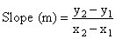
Example 1: Find the slope of the line between Point R (2, 4) and Point S (1, 3).
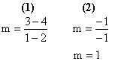
Step 1: Substitute the given coordinate points into the formula.
Step 2: Simplify the fraction.
Answer: The slope of the line is 1.
The Point-Slope form for the equation of a line:
Example 2: Use the following points to find the equation of the line.
Point T (7, -3)
Point U (-4, 6)
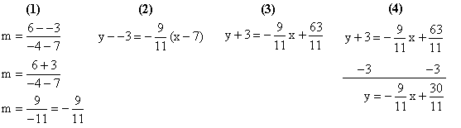
Step 1: Solve for the slope of the line between Point T and Point U.
Step 2: Use one of the coordinate points and the slope and substitute them into the Point-Slope form for the equation of a line.
Step 3: Simplify both sides of the equation.
Step 4: Subtract 3 from both sides of the equation.
The equation of the line that passes through (7, -3) and (-4, 6) is y = -9/11x + 30/11.

