Summer Packet 2

Student Name: ___________________________

Class: ___________________________

Date: ___________________________

Instructions: Read each question carefully and select the correct answer.

1. The following box-and-whisker plot shows the change in water temperatures each week throughout the year. What is the first quartile for this data?
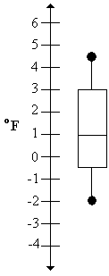
A. 1º
B. - 2º
C. 3º
D. - 0.5º

2. The following box-and-whisker plot shows the test scores from Mr. Nguyen's class. What percentage of the students scored 60 points or higher?
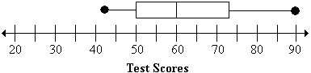
A. 80%
B. 10%
C. 50%
D. 25%

3. The calorie content of various types of potato chips are represented in the box-and-whisker plot below. What is the lowest calorie content value for the potato chips shown here?
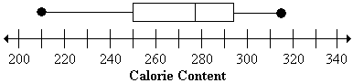
A. 250 calories
B. 210 calories
C. 200 calories
D. 278 calories

4. The calorie content of various canned soups are represented in the box-and-whisker plot below. What is the median value for this data?
A. 263 calories
B. 250 calories
C. 278 calories
D. 294 calories

5. The stem-and-leaf plot below shows the number of different species of fish living in the Washington County rivers. How many rivers have more than 40 species of fish?
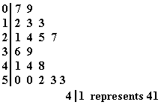
A. 10 rivers
B. 5 rivers
C. 6 rivers
D. 8 rivers

6. The stem-and-leaf plot below shows the test scores from students in Mr. Poli's class. What was the highest test score in the class?
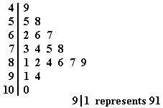
A. 10
B. 100
C. 8,124,679
D. 914

7. What is the minimum value of the data set represented in the stem-and-leaf plot?
A. 0
B. 4
C. 49
D. 10

8. The stem-and-leaf plot below shows the number of baskets made by players during a week of basketball practice. How many people made 35 baskets during the week?
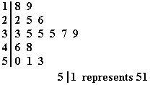
A. 3 players
B. 0 players
C. 6 players
D. 1 players

9. Calculate the slope of the line between the points (5, 3) and (4, - 3).
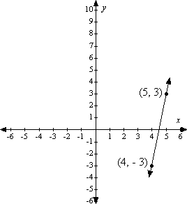
A.
B. 6
C. 0
D. - 6

10. Calculate the slope of the line between the points (-2, - 4) and (1, 5).
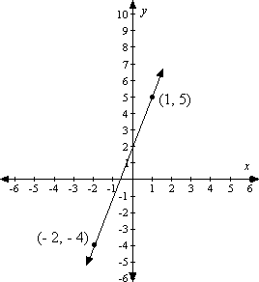
A.
B. 3
C. - 3
D.

11. Calculate the slope of the line between the points (- 3, 10) and (3, 5).
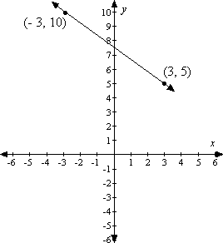
A.
B.
C.
D.

12. Calculate the slope of the line between the points (- 1, 6) and (4, - 5).
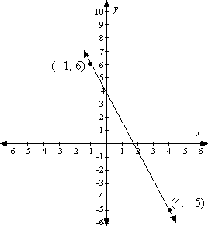
A.
B.
C.
D. 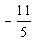

13. Evaluate the expression with x = 16.
(x + 45) - 80
A. -19
B. 35
C. -35
D. 51

14. Solve for x.
(6x + 2) - 4 = 10
A. x = 4/3
B. x = 8/3
C. x = 2
D. x = 11/3

15. Solve for x.
15 - (2x - 4) = 5
A. x = -3
B. x = 3
C. x = -7
D. x = 7

16. Evaluate the expression with m = -5.
3(2m - 5) - 8
A. 7
B. -23
C. -53
D. 37

17. Find the area of the following rectangle.
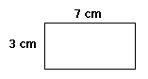
A. 20 square centimeters
B. 21 square centimeters
C. 10 square centimeters
D. 4 square centimeters

18. Find the area of the following figure.
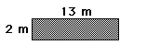
A. 15 square meters
B. 30 square meters
C. 13 square meters
D. 26 square meters

19. Find the area of the following figure.
A. 136 square feet
B. 25 square feet
C. 50 square feet
D. 100 square feet

20. Find the area of the following figure.
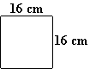
A. 256 square centimeters
B. 32 square centimeters
C. 64 square centimeters
D. 148 square centimeters

21. Janet earned $1.50 for walking her neighbor's dog. She bought a stick of gum for $0.12 and a magazine for $0.67. How much money did she have left over?
A. $0.71
B. $0.95
C. $2.05
D. $0.79

22. JoAnna receives $5.50 for her weekly allowance. She owed Jacob $1.25. She paid Jacob the money she owed him and decided to buy lunch for $2.55. How much money does she have left?
A. $2.55
B. $1.70
C. $5.50
D. $1.95

23. The newspaper costs $3.52 per week for delivery. If you buy an 8-week subscription, you only pay $25.00. How much do you save by purchasing the 8-week subscription instead of paying weekly?
A. $25.00
B. $28.16
C. $3.16
D. $28.52

24. At the zoo, it costs 2 dollars to ride on the tram and 4 dollars to see the show. If 20 people did both, how much money would the zoo get?
A. $26
B. $14
C. $160
D. $120

25. Solve for b.
5(b + a) = 27b
A. 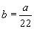
B. 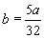
C. 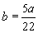
D. 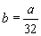

26. Solve for r.
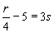
A. r = 2s
B. r = 4(8s)
C. r = 4(3s - 5)
D. r = 4(3s + 5)

27. Solve for m.
2mn - 3 = 16
A. 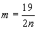
B. 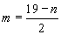
C. 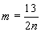
D.

28. Solve for z.
8 + 4zy = 21
A. z = 13 - 4y
B. z = 13(4y)
C. 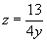
D. 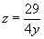

29. Wendell ate 3.5 cakes in the morning. He ate 2.5 cakes in the afternoon. He ate 7.4 cakes in the evening. How many cakes did he eat?
A. 13.4 cakes
B. 7.4 cakes
C. 12.14 cakes
D. 1.4 cakes

30. Tatiana spent $4.98 on party hats, $3.59 on blowers, and $16.88 on a cake. How much money did Tatiana spend?
A. $10.58
B. $102.58
C. $27.45
D. $25.45

31. Damian raced his bike 7.89 miles, swam 15.01 miles, and ran 12.4 miles. How many miles did Damian bike, swim and run?
A. 13.14 miles
B. 23.04 miles
C. 35.3 miles
D. 25.2 miles

32. The Recycling Company collected 230.45 tons of aluminum cans, 78.898 tons of newspaper, and 502.609 tons of glass bottles. How many tons of recycling was collected?
A. 5945.52 tons
B. 8119.57 tons
C. 594.552 tons
D. 811.957 tons

33. Divide.
A. 1.0225
B. 12.25
C. 10.225
D. 1.225

34.
A. 58.8
B. 588.8
C. 5.888
D. 5.8R8

35.
A. 22.827321
B. 0.022827
C. 228.273
D. 2.282732

36.
A. 4.42
B. 4.42 R75
C. 4.4275
D. 44,275

37. Jorge and his family went to an amusement park over spring break. They spent $500.00. The pie graph shows how the $500.00 was divided over the trip. Use the pie graph to answer the question.
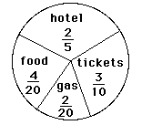
How much money did Jorge and his family spend on food?
A. $250.00
B. $100.00
C. $300.00
D. $150.00

38. Mia wanted to show how she spent her time. She made a pie graph of her typical 24 hour day. Use the pie graph to answer the question.
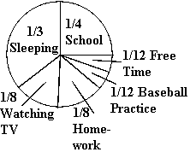
How many hours does Mia spend at baseball practice?
A. 1 hour
B. 2 hours
C. 3 hours
D. 4 hours

39. Mia wanted to show how she spent her time. She made a pie graph of her typical 24 hour day. Use the pie graph to answer the question.
How many hours does Mia spend sleeping?
A. 8 hours
B. 6 hours
C. 12 hours
D. 9 hours

40. Grant built a sandcastle. He used 1,000 pounds of sand. The pie graph shows how the 1,000 pounds of sand was divided in building the sandcastle. Use the pie graph to answer the question.
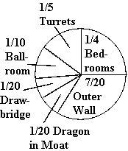
How many pounds of sand did Grant use to build the ballroom?
A. 50 pounds of sand
B. 150 pounds of sand
C. 100 pounds of sand
D. 200 pounds of sand

41. Reduce all fractions to lowest terms.
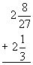
A.
B. 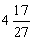
C.
D.

42. Reduce answer to lowest terms.
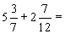
A.
B.
C.
D. 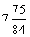

43. Reduce answer to lowest terms.
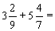
A.
B.
C.
D.

44. Reduce all fractions to lowest terms.
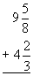
A.
B. 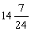
C. 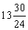
D. 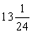

45. Reduce answer to lowest terms.
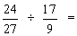
A.
B.
C.
D. 5

46. Reduce answer to lowest terms.
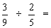
A.
B.
C.
D.

47. Reduce answer to lowest terms.
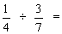
A.
B.
C.
D.

48. Reduce answer to lowest terms.
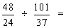
A. 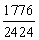
B. 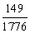
C.
D.

49. What is 69.399 rounded to the nearest whole number?
A. 70
B. 69
C. 60
D. 68

50. What is 899.23 rounded to the nearest whole number?
A. 898
B. 899.2
C. 900
D. 899

51. What is 45.78 rounded to the nearest whole number?
A. 45
B. 46
C. 45.8
D. 45.9

52. What is 19.19 rounded to the nearest whole number?
A. 19
B. 20
C. 19.2
D. 19.5

53. Add.
- 89 + - 431 =
A. 342
B. - 342
C. 520
D. - 520

54. -72 + 63 =
A. -135
B. 9
C. -9
D. 135

55. -24 + 13 =
A. 11
B. 37
C. -37
D. -11

56. -4 + -7 =
A. 3
B. -11
C. -3
D. 11

57. What is the area of the figure?
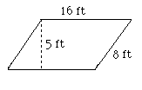
A. 80 square feet
B. 128 square feet
C. 25.6 square feet
D. 48 square feet

58. Find the area of the parallelogram.
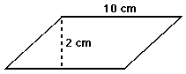
A. 40 square centimeters
B. 24 square centimeters
C. 12 square centimeters
D. 20 square centimeters

59. Find the area of the parallelogram.
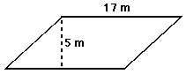
A. 22 square meters
B. 85 square meters
C. 42.5 square meters
D. 44 square meters

60. Find the area of the parallelogram.
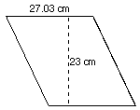
A. 25.015 square centimeters
B. 50.03 square centimeters
C. 310.845 square centimeters
D. 621.69 square centimeters

61. Solve for the value of x.
A. x = 78.5
B. 12 < x < 13
C. x = 13
D. 78 < x < 79

62. Find the equivalent form.
A.
B.
C.
D.

63. Find the equivalent form.
A. 625
B. 5
C. 12.5
D. 250

64. Fill in the blank.
The square root of 50 is ____________________.
A. less than 7
B. between 5 and 7
C. between 7 and 8
D. greater than 8

65. What is the area of a circle with a radius of 8.1 meters?
Round your answer to the nearest hundredth.
A. 50.87 square meters
B. 206.02 square meters
C. 25.43 square meters
D. 12.72 square meters

66. What is the area of a circle with a diameter equal to 12 meters?
A. 113.04 square meters
B. 452.16 square meters
C. 37.68 square meters
D. 144 square meters

67. What is the area of a circle with a radius equal to 9 meters?
A. 25.8 square meters
B. 81 square meters
C. 56.52 square meters
D. 254.34 square meters

68. What is the area of Circle B?
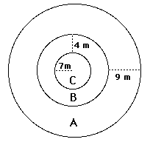
Round your answer to the nearest hundredth.
A. 1,256 square meters
B. 50.24 square meters
C. 34.54 square meters
D. 379.94 square meters

69. The following graph represents Samantha's monthly budget.
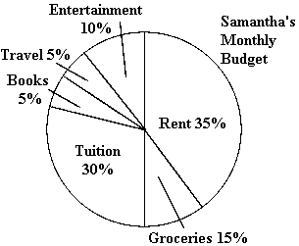
What percent does Samantha spend on books?
A. 5%
B. 10%
C. 20%
D. 50%

70. The following graph shows the number of books that Charles and Abbey read each month.
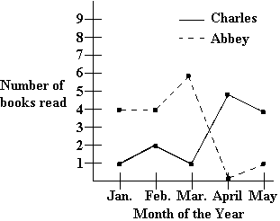
In which month did Charles read the most books?
A. February
B. March
C. April
D. May

71. The following graph shows the number of books that Charles and Abbey read each month.
Who read the most books?
A. Charles
B. Abbey

72. The following is a graph showing the sales from three cellular phone stores.
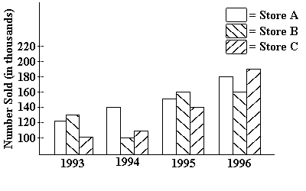
Which store's sales did not increase each year?
A. Store A
B. Store B
C. Store C
D. None

73. Solve by completing the square.
x² + x - 10 = 0
A. x = - 2 or x = 5
B. 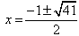
C.
D. No Real Roots

74. Use the Pythagorean theorem to solve for x.
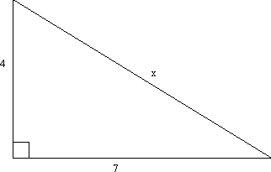
A.
B.
C.
D.

75. Solve the following equation.
A.
B.
C.
D.

76. Find the characteristic that describes the graph of
A. The parabola crosses the x-axis at x = -6 and x = 1.
B. The x-coordinate of the vertex is 49/4.
C. The axis of symmetry is x = 5/2.
D. The graph opens up.

77. Divide.
568 ÷ (- 71)
A. - 8
B. - 18
C. 18
D. 8

78. -48 ÷ -8 =
A. 6
B. -384
C. -6
D. 384

79. 275 ÷ -5 =
A. 1375
B. -1375
C. -55
D. 55

80. Choose the symbol that replaces the question mark.
-2080 ÷ -65 ? -1748 ÷ 23
A. =
B. >
C. <

81. What is the value of z?
26.5 = z + (2.3 + 7.7)
A. 2.65
B. 36.5
C. 16.5
D. 26.5

82. Solve for y.
18 + y = 45
A. y = -27
B. y = 27
C. y = -63
D. y = 63

83. Solve for t.
4 - t = 10
A. t = 14
B. t = -14
C. t =6
D. t = -6

84. Solve for a.
a - -6 = 12
A. a = 6
B. a = -6
C. a = 18
D. a = -18

85. What is the value of b?
10.75 = 4.3b
A. 6.45
B. 2.5
C. 46.225
D. 14.75

86. Solve for t.
7t = -56
A. t = -392
B. t = 392
C. t = -8
D. t = 8

87. Solve for x.
8x/9 = -4
A. x = 9/2
B. x = -9/2
C. x = 32/9
D. x = -32/9

88. What is the value of a?
a
- = 24
6
A. 144
B. 4
C. 30
D. 72

89. What is the value of x?
x = 9y
y = 5
A. x = 1.8
B. x = 45
C. x = 14
D. Problem cannot be solved with the given information.

90. Solve for m.
m = n - 8
p = n + 2
A. m = -2
B. m = -10
C. m = 10
D. Problem cannot be solved with the given information.

91. Solve for a.
a = 3c
c= -2
A. a = 6
B. a = -6
C. a = -3/2
D. Problem cannot be solved with the given information.

92. What is the value of h?
g = -7.1
h = 3 - 10g
A. h = -68
B. h = 68
C. h = 74
D. Problem cannot be solved with the given information.

93. Given the coordinate points C(-1, 8), L(5, -2), and H(-6, y), write an equation for line CL and find the y-coordinate for point H (-6, y) on the line CL.
A. y = 1.67
B. y = 16.4
C. y = 16 1/3
D. y = -5/3

94. Given the coordinates (1, 5) and (2, 9), find the equation of the line.
A. x + 4y = 2
B. -4x + y = 1
C. -x + 4y = 19
D. 4x + y = 9

95. Given the coordinates (2, 2) and (4, -1), find the equation of the line.
A. 3x + 2y = - 1
B. x + 2y = 3
C. - x + 2y = 1
D. 3x + 2y = 10

96. Given the coordinates A(-3, 5) and C(7, -1), find the equation of the line.
A. y = -3/5x + 3 1/5
B. y = -3/5x - 16/5
C. y = -3/5x
D. y = 19/5x

