Summer Packet

Student Name: ___________________________

Class: ___________________________

Date: ___________________________

Instructions: Read each question carefully and select the correct answer.

1. 3.78
+ 2.12
A. 5.80
B. 1.66
C. 1.96
D. 5.90

2. 10.68
+ 5.74
A. 15.14
B. 16.42
C. 5.44
D. 15.134

3. 6.05
+ 7.89
A. 13.04
B. 13.84
C. 11.05
D. 13.94

4. 6.47
+ 5.99
A. 11.1316
B. 12.1316
C. 11.46
D. 12.46

5. Marina started with 1.34 pies. Lorna gave Marina 5.78 more pies.
How many pies does Marina have now?
A. 4.44 pies
B. 712 pies
C. 7.12 pies
D. 444 pies

6. Justin ran 1.2 miles on Saturday and 3.9 miles on Sunday.
How many miles did Justin run in all?
A. 5.1 miles
B. 2.7 miles
C. 4.1 miles
D. 4.11 miles

7. Linda earned $3.35 babysitting for the Kramer family. She earned $4.55 babysitting for the Washington family.
How much money did Linda earn for babysitting?
A. $0.12
B. $1.20
C. $0.79
D. $7.90

8. Sal weighs 32.4 pounds.
David weighs 40.1 pounds.
How much do Sal and David weigh together?
A. 6.3 pounds
B. 72.5 pounds
C. 8.41 pounds
D. 324.01 pounds

9. 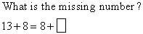
A. 12
B. 14
C. 13
D. 15

10. 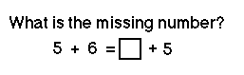
A. 11
B. 1
C. 6
D. 10

11. 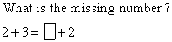
A. 5
B. 3
C. 4
D. 2

12. 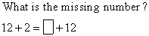
A. 12
B. 1
C. 3
D. 2

13. 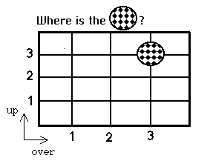
A. over 3, up 3
B. over 2, up 1
C. over 1, up 3
D. over 3, up 1

14. 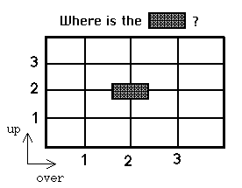
A. over 3, up 2
B. over 2, up 1
C. over 1, up 3
D. over 2, up 2

15. 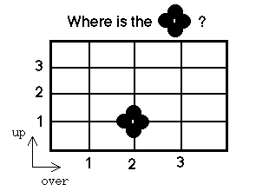
A. over 1, up 3
B. over 2, up 1
C. over 3, up 2
D. over 2, up 2

16. 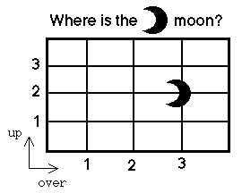
A. over 1, up 2
B. over 2, up 1
C. over 3, up 2
D. over 3, up 1

17. 84.82
+ 91.19
A. 176.1
B. 175.101
C. 176.01
D. 175.01

18. 13.69
+ 18.45
A. 31.114
B. 32.04
C. 32.14
D. 31.04

19. 63.01
+ 15.99
A. 78.100
B. 79
C. 79.1
D. 78.01

20. 57.67 + 89.73 =
A. 116.30
B. 147.4
C. 171.33
D. 146.04

21.
A.
B.
C.
D.

22. 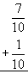
A.
B.
C.
D.

23.
A.
B.
C.
D.

24. 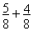
A.
B.
C.
D.

25. Mike has 7 2/3 pounds of chocolate. His father gave him another 2 pounds.
Which of these number sentences shows how to find how much chocolate Mike has?
A. 7 2/3 - 2 =
B. 7 2/3 x 2 =
C. 7 2/3 + 2 =
D. 7 2/3 ÷ 2 =

26. Liberty picked 32 tulips from her garden. She wants to give the same number of tulips to each of her 8 teachers. How would you figure out how many tulips each teacher would get?
A. 32 8 = 256 tulips
B. 32 + 8 = 40 tulips
C. 32 - 8 = 24 tulips
D. 32 ÷ 8 = 4 tulips

27. There are 42 students attending the play. The playhouse has 7 rows of seats.
Which of these number sentences shows how to find the number of students that will be seated in each row?
A. 42 x 7 =
B. 42 - 7 =
C. 42 + 7 =
D. 42 ÷ 7 =

28. There are 4 new players on the soccer team. Each player needs 3 new shirts.
Which of these number sentences shows how to find the number of shirts needed for the players?
A. 4 + 3 =
B. 4 - 3 =
C. 4 x 3 =
D. 4 ÷ 3 =

29. The numbers in Column A have been changed to the numbers in Column B by using a specific rule.
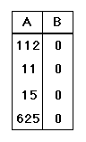
Which number sentence shows that rule?
A. A + 0 = B
B. A x 0 = B
C. A - 20 = B
D. A x 1 = B

30. A number machine uses a special pattern to change one number into another number. The following number machine changes 42 into 7, 66 into 11, and 36 into 6.
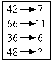
Using the same number machine, what will 48 be changed into?
A. 8
B. 6
C. 13
D. 12

31. Use the given rule to complete the table.
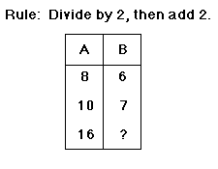
A. 16
B. 15
C. 24
D. 10

32. Use the given rule to complete the table.
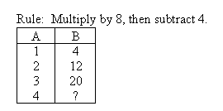
A. 28
B. 8
C. 40
D. 24

33. Average the following numbers: 225, 171, 198, 189, 135, 252, 180, 144, 180.
A. 171
B. 1,674
C. 186
D. 166

34. Average the following numbers: 16, 7, 7, 15, 5.
A. 10
B. 5
C. 50
D. 25

35. Average the following numbers: 250, 30, 855, 65, 780, 100, 45, 70, 115, 60.
A. 2370
B. 227
C. 234
D. 237

36. Average the following numbers: 28, 21, 70, 84, 98, 14, 35.
A. 350
B. 45
C. 250
D. 50

37. Reduce all fractions to lowest terms.
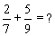
A.
B.
C.
D.

38. Reduce all fractions to lowest terms.
A.
B.
C.
D.

39. Reduce all fractions to lowest terms.
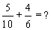
A.
B.
C.
D.

40. Reduce all fractions to lowest terms.
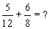
A.
B.
C.
D.

41. On the following number line, what is the difference between point D and point A?
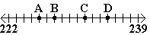
A. 6
B. 9
C. 2
D. 7

42. Use the following number line to choose the point that is at 264.
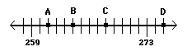
A. A
B. B
C. C
D. D

43. Use the number line to solve the equation:
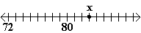
point X + 5 =
A. 84
B. 80
C. 88
D. 85

44. On the following number line, what is the difference between point D and point C?
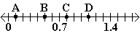
A. 2
B. 0.2
C. 3
D. 0.3

45. Which of the following word problems can be solved using the equation 12 8 = x?
A. There are 12 different animals that Jose wanted to see at the zoo. If he has already seen 8 of them, how many more does he have left to see?
B. Each day for the past 12 days, Bill drank 8 glasses of water. How many glasses of water did he drink in all?
C. During the last blizzard, 12 inches of snow fell on the first day and 8 inches of snow fell on the second day. How many inches of snow fell in the two days?
D. There are 12 markers in Mr. Smith's preschool class. If the 8 students in the class are making cards for their parents, how many markers can each student use at a time?

46. Which of the following word problems can be solved using the equation 33 - 4 = x?
A. Sasha had 33 dollars saved for her new bicycle and was then paid 4 dollars for washing cars. How much money does she have now?
B. The swimming pool had 33 gallons of water in it. When the kids went swimming, they splashed 4 gallons of water out of the pool. How much water was left in the pool?
C. Josh's mom made 33 cookies for the family to decorate for the holidays. If there are 4 people, how many cookies will each of them get to decorate?
D. If 33 people each recycled 4 cans one day, what is the total number of cans recycled by them that day?

47. Which of the following word problems can be solved using the equation 19 + 9 = x?
A. Marta had 19 pieces of candy in her backpack. Over the next few days, she gave 9 pieces away. How many pieces of candy did she have left?
B. John's family brought 19 marshmallows for the 9 campers to share when they were camping. How many marshmallows did each person get?
C. There were 19 rainy days this month and 9 rainy days last month. How many rainy days were there in the past two months?
D. Alejandro walked for 19 minutes each day for the past 9 days. In all, how many minutes did he walk?

48. Which of the following word problems could be solved using the equation 25 + 4 = x?
A. The Chen family had 25 firewood logs in their back yard. The parents asked their 4 children to move the logs closer to the house. How many will each of the children need to move?
B. One banana costs 25 cents. Vida bought 4 bananas. How much money (without tax) will the bananas cost?
C. Galina had 25 students in her class. Then 4 new students came into her class. Now how many students are in Galina's class?
D. Jason had 25 paper clips but lost 4 of them. How many paper clips does he have now?

49. In the last seven years of school, Taska has had eleven different teachers. Nine of her teachers were female. Based on this information, what is the experimental probability that the next teacher she has will be a male?
A.
B.
C.
D.

50. Out of the last six times that Silvia's family went to the zoo, they were only able to see the cheetahs once. Based on this information, what is the experimental probability that the next time Silvia's family goes to the zoo that they will see the cheetahs?
A.
B.
C.
D.

51. In the last year, Darrell and Janice went to the movies often. The chart below shows the number of movies they attended this past year.
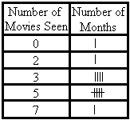
Based on this information, what is the experimental probability that they will see three movies next month?
A.
B.
C.
D.

52. In nine out of her last thirteen hockey games, Lucia has scored at least one goal. Based on this information, what is the experimental probability that Lucia will score at least once in the next game?
A.
B.
C.
D.

53. Add.
1⁹ + 19 =
A. 28
B. 20
C. 38
D. 29

54. Add.
9³ + 3³ =
A. 756
B. 36
C. 1,728
D. 738

55. Subtract.
1,300 - 6⁴ =
A. 868
B. 1,296
C. 1,276
D. 4

56. Subtract.
2⁵ - 32 =
A. 20
B. 32
C. 0
D. 64

57. What is another way to write:
A. 6 x 6 x 6 x 6 x 6 x 6 x 6
B. 9 x 9 x 9 x 9 x 9 x 9
C. 9 x 6 x 9 x 6
D. 6 x 6 x 6 x 6 x 6 x 6 x 6 x 6 x 6

58. What is another way to write:
A. 4 x 4
B. 4 x 2
C. 4 x 4 x 4
D. 2 x 2 x 2 x 2

59. What is another way to write:
A. 10 x 10
B. 2 x 10
C. 2 x 2 x 2 x 2 x 2 x 2 x 2 x 2 x 2 x 2
D. 10 x 10 x 10

60. What is another way to write:
A. 10 x 5 x 5
B. 10 x 10 x 10 x 10 x 10
C. 5 x 5 x 5 x 5 x 5 x 5 x 5 x 5 x 5 x 5
D. 10 x 10 x 10 x 10

61. What is 9.2 rounded to the nearest whole number?
A. 9.5
B. 8
C. 9
D. 10

62. Which of the following formulas should you use to estimate 2,795 + 6,299 to the nearest thousand?
A. 3,000 + 6,000
B. 2,500 + 6,000
C. 2,000 + 6,000
D. 2,800 + 6,300

63. What is 19.19 rounded to the nearest whole number?
A. 19
B. 20
C. 19.2
D. 19.5

64. Which of the following formulas should you use to estimate 45.3 x 7.9?
A. 45 x 8
B. 44 x 7
C. 45 x 7
D. 44 x 8

65. What type of angle is shown below?
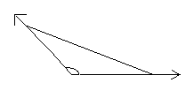
A. acute angle
B. right angle
C. isosceles angle
D. obtuse angle

66. Which angles are right angles?
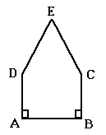
A. ABC and BCE
B. BAD and DEC
C. DAB and ABC
D. DEC and ECB

67. Which angle is acute?
A. ADE
B. ABC
C. ECB
D. DEC

68. Which choice best completes the sentence?
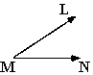
Angle LMN is...
A. an acute angle.
B. an obtuse angle.
C. a right angle.
D. a scalene angle.

69. 52 + -60 =
A. 8
B. -112
C. 112
D. -8

70. Add.
- 61 + - 72 =
A. - 133
B. 133
C. - 11
D. 11

71. -4 + -7 =
A. 3
B. -11
C. -3
D. 11

72. -5 + -23 =
A. -28
B. 18
C. -18
D. 28

73. Which of the following numbers is greater than the others?
A. 0.5
B. 5
C. 50%
D. 1/5

74. Put the following integers in order from least to greatest.
369, - 271, 45, 98, - 39, 12
A. - 39, - 271, 12, 45, 98, 369
B. - 271, - 39, 12, 45, 98, 369
C. 12, - 39, 45, 98, - 271, 369
D. 369, 98, 45, 12, - 39, - 271

75. Which of the following numbers is greater than the others?
A. -100
B. -100%
C. -99
D. -9%

76. Which of the following could be the value of y?
7.008 < y < 9.615
A. 7/9
B. 7.1
C. 9.701
D. 8%

77. The Groovy Garment Clothing Company has 13 blue sweaters and 17 green sweaters.
What is the ratio of green sweaters to blue sweaters?
A. 13:17
B. 30:17
C. 17:13
D. 4:17

78. Is the following proportion TRUE or FALSE?
5 6
- = -
7 9
A. True
B. False

79. What is the ratio of one side to the perimeter?
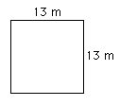
A. 13:52 m
B. 52:13 m
C. 1:52 m
D. 1:13 m

80. What is the ratio of the height to the base?
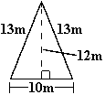
A. 12:13 m
B. 12:10 m
C. 13:10 m
D. 10:36 m

81. Which mathematical expression represents the word expression?
The sum of a number and nineteen.
A. n/19
B. 19n
C. n + 19
D. n - 19

82. For t = 26, find t + -20.
A. 6
B. -6
C. 46
D. -46

83. Determine the value of the question mark.
4 + ? = n, when n = -6
A. 2
B. -2
C. 10
D. -10

84. For x = -10, find 36 + x.
A. -26
B. 26
C. -46
D. 46

85. Evaluate the expression for y =3.
(7 - 5y)
A. -8
B. -1
C. 22
D. 15

86. If y = 8, then 5y = ?
A. 13
B. 3
C. 40
D. 1.6

87. Evaluate the expression for m =2 and n = -3.
3m - 8n
A. -25
B. -18
C. 30
D. 7

88. Evaluate the expression for r = -5.
-3 - 2r
A. -13
B. 13
C. -7
D. 7

89. Choose the symbol that replaces the question mark.
-2(14 ÷ 7) ? 3(-26 ÷ 2)
A. =
B. >
C. <

90. -150 ÷ 25 =
A. -3750
B. -6
C. 3750
D. 6

91. Choose the symbol that replaces the question mark.
-2080 ÷ -65 ? -1748 ÷ 23
A. =
B. >
C. <

92. (-12 x 3) ÷ (6 x 2) =
A. 3
B. -2
C. -3
D. 2

93. Simplify.
21.693 - (- 3.412) =
A. 25.105
B. 18.281
C. - 25.105
D. - 18.281

94. Subtract.
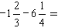
A. 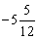
B. 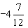
C. 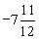
D. 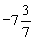

95. Simplify.
- 87.914 - 3.009 =
A. - 84.905
B. 84.905
C. - 90.923
D. 90.923

96. -6.8 + -2.4 - 1.1 =
A. 10.3
B. 3.3
C. -10.3
D. -3.3

97. Find the correct expression.
Twelve less than a number x.
A. 12 - x
B. 12 + x
C. x - 12
D. x + 12

98. Which phrase best matches the expression x - 14?
A. 14 decreased by a number
B. a number decreased by 14
C. a number divided by 14
D. 14 multiplied by a number

99. The width of a crate is 13 inches less than the crate's length.
Width = W
Length = L
Which of the following expressions correctly represents the width of the crate?
A. W + L
B. L - 13
C. W - 13
D. L + 13

100. Evaluate the expression for t = -3
3t - 2
A. 11
B. -11
C. 7
D. -7

101. Evaluate the expression for n = 3.
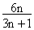
A. 2
B. 9/5
C. 6/7
D. 6/5

102. Evaluate the expression for n = -8.
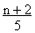
A. 2
B. -2
C. 1.2
D. -1.2

103. Evaluate the expression for t = -2.
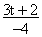
A. 1
B. -1
C. 2
D. -2

104. Evaluate the expression for t = -2.
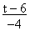
A. 1
B. -1
C. 2
D. -2

105. Use the table to answer the question.
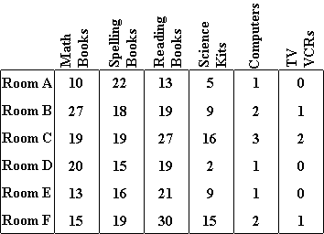
How many more reading textbooks does room C have than room A?
A. 14 reading textbooks
B. 13 reading textbooks
C. 40 reading textbooks
D. 15 reading textbooks

106. Use the table to answer the question. Round to the nearest cent when necessary.
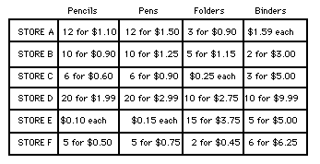
How much more is one binder at Store C than at Store A?
A. $1.66
B. $0.08
C. $1.67
D. $0.07

107. Use the table to answer the question. Round to the nearest cent when necessary.
How much would one pen cost at Store A?
A. $0.13
B. $0.12
C. $0.18
D. $0.10

108. Use the table to answer the question.
Which rooms have no TV/VCRs?
A. Rooms A, B, and C
B. Rooms B, D, and E
C. Rooms A, D, and E
D. Rooms D, E, and F

109. Use the spinner to answer the question.
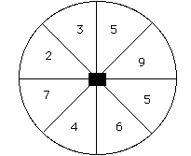
How many times can you expect to spin a 5 if you spin 12 times?
A. 4
B. 3
C. 5
D. 2

110. Ellen won 4 out of 6 spelling contests.
What is the probability that she will win the next contest?
A. 67%
B. 15%
C. 24%
D. 80%

111. Use the spinner to answer the question.
If you spin twice, how many times can you expect to spin a 9?
A. 0.22
B. 4.5
C. 0.25
D. 1.8

112. Kimberly was voted softball's "Most Valuable Player" for 2 out of the past 5 seasons.
What is the probability that Kimberly will be "Most Valuable Player" this year?
A. 10%
B. 40%
C. 25%
D. 7%

113. You roll one die and then toss one coin. Find the probability that the number on the die is 4 or less, and that the coin is heads.
A. 1/8
B. 1/2
C. 1/3
D. 1/4

114. A family of 5 (2 adults and 3 children) are at a masquerade party. The children are wearing masks, so you cannot discern the sex of the 2 older children. The youngest child is a boy. What is the probability that this family has at least 1 other boy?
A. 1/4
B. 1/2
C. 2/3
D. 3/4

115. You draw one card from a full deck of 52 cards and set the card aside. Then, you draw a second card. Find the probability that each card you've drawn is a spade.
A. 4/52
B. 12/51
C. 1/156
D. 1/17

116. Janet tossed one nickel. Then, she tossed another nickel. What is the sample space for both tosses?
A. HHH, TTT, HTH, THT
B. HH, HT, TT,
C. HH, HT, TH, TT
D. HHH, TTT, HTH

